**Practical :01**

**AIM:** Study Weka tool.

**Introduction to Weka:**

WEKA - an open source software provides tools for data preprocessing, implementation of several Machine Learning algorithms, and visualization tools so that you can develop machine learning techniques and apply them to real-world data mining problems.

**Steps for downloading and installing Weka:**

Step 1:First we go to website.

Step 2: Then download Weka.

Step 3:After download install Weka. Click on next to continue.

Step 4: Click on I agree to continue.

Step 5: Click on next to continue.

Step 6: Click on install.

Step 7: The installation process starts.

Step 8:After the process completed click on next.

Step 9: Click on finish .

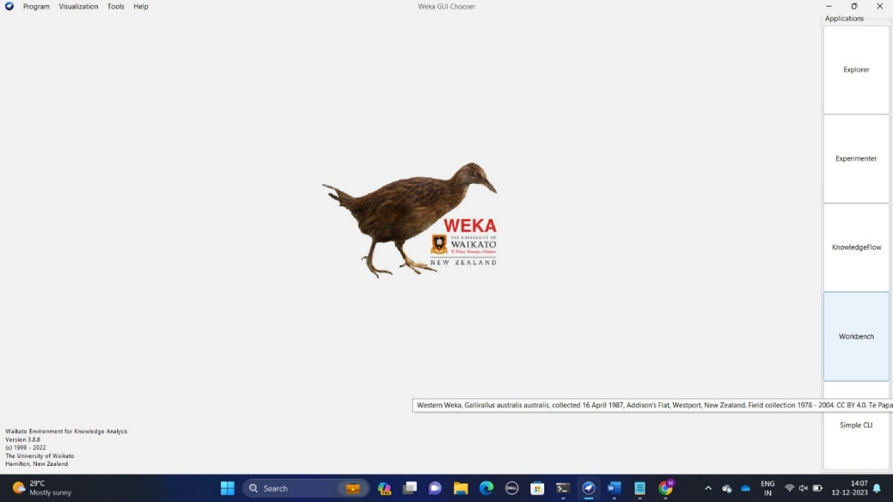

Figure1: Dashboard of weka

Now explore the tools of Weka

Step 1: Open Weka and go to explorer.

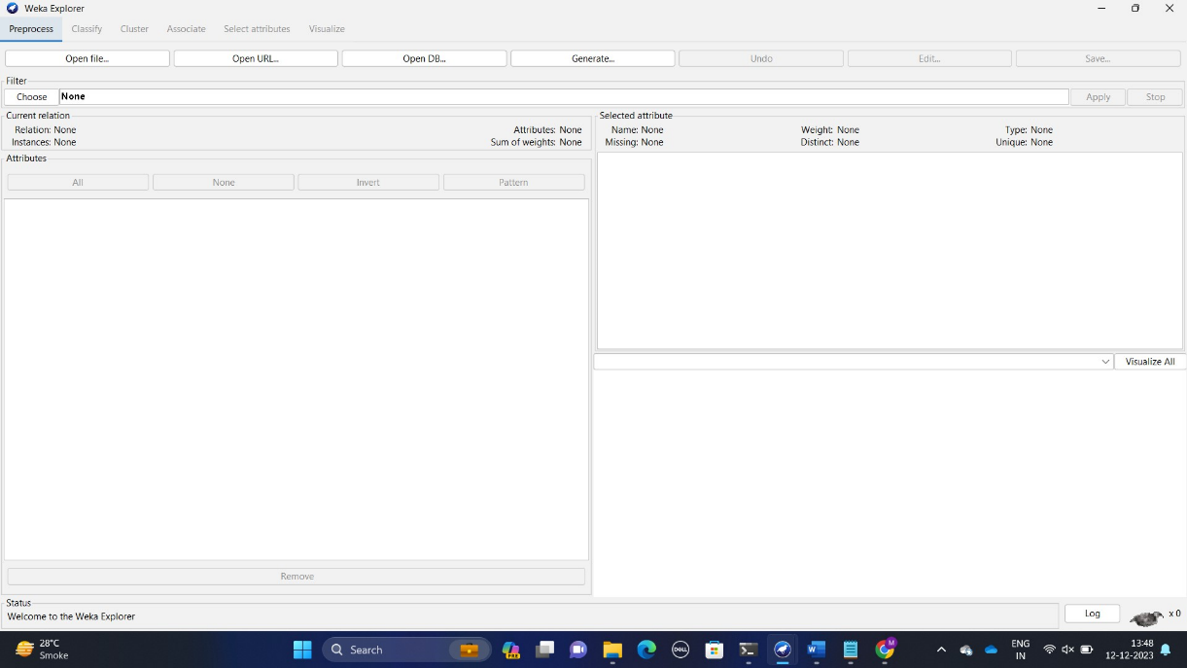

Figure 2: Explorer menu

Step 2: Close the explorer and open experiment.

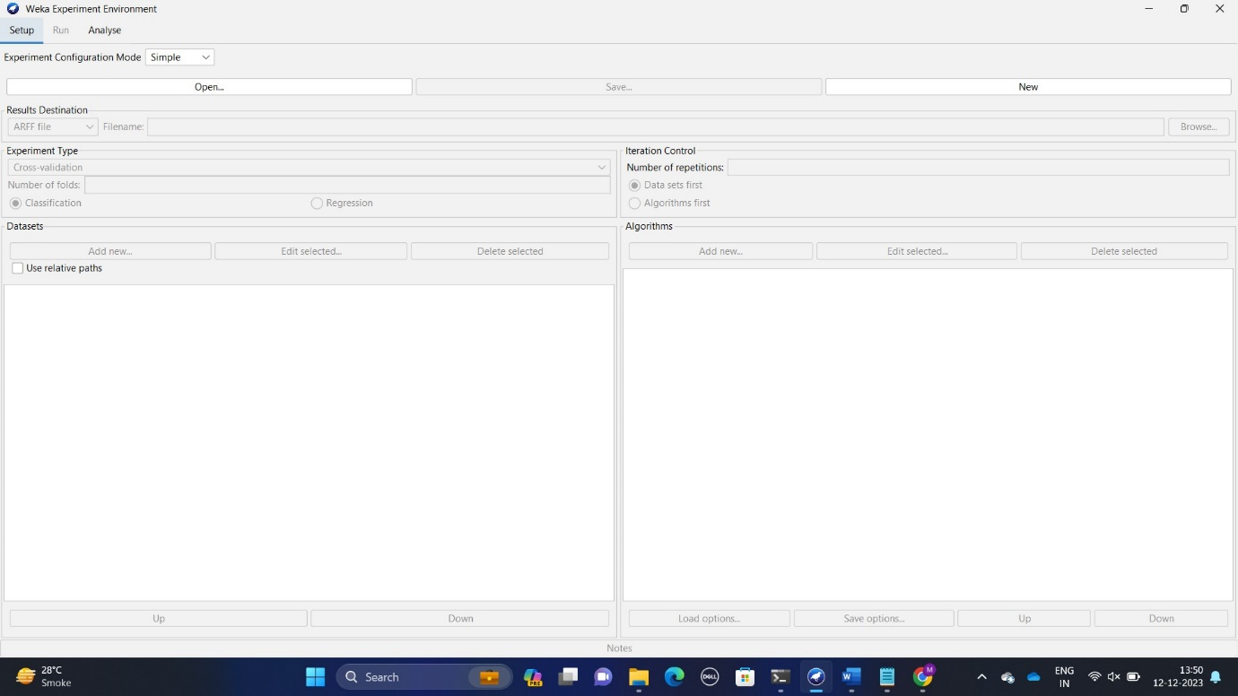

Figure 3:Experiment menu

Step 3: Close the experiment and open knowledge flow

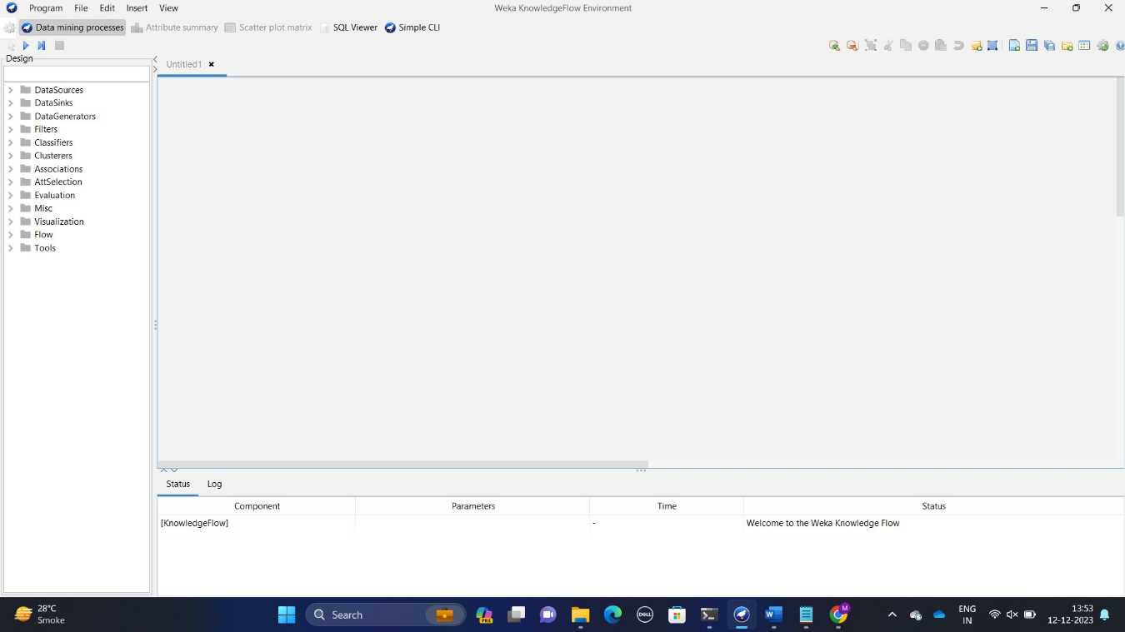

Figure 4: Knowledge flow menu

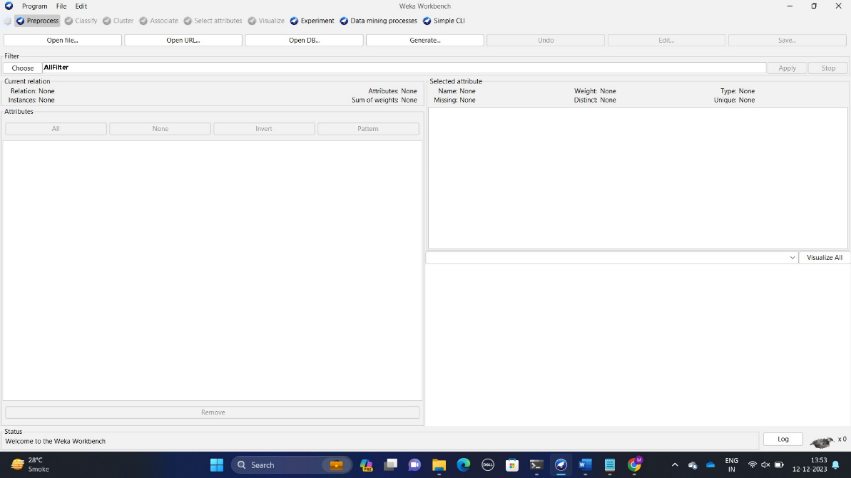Step 4: Close the knowledge flow and open workbench.

Figure 5: Workbench menu

Step 5: Close the workbench and open CLI

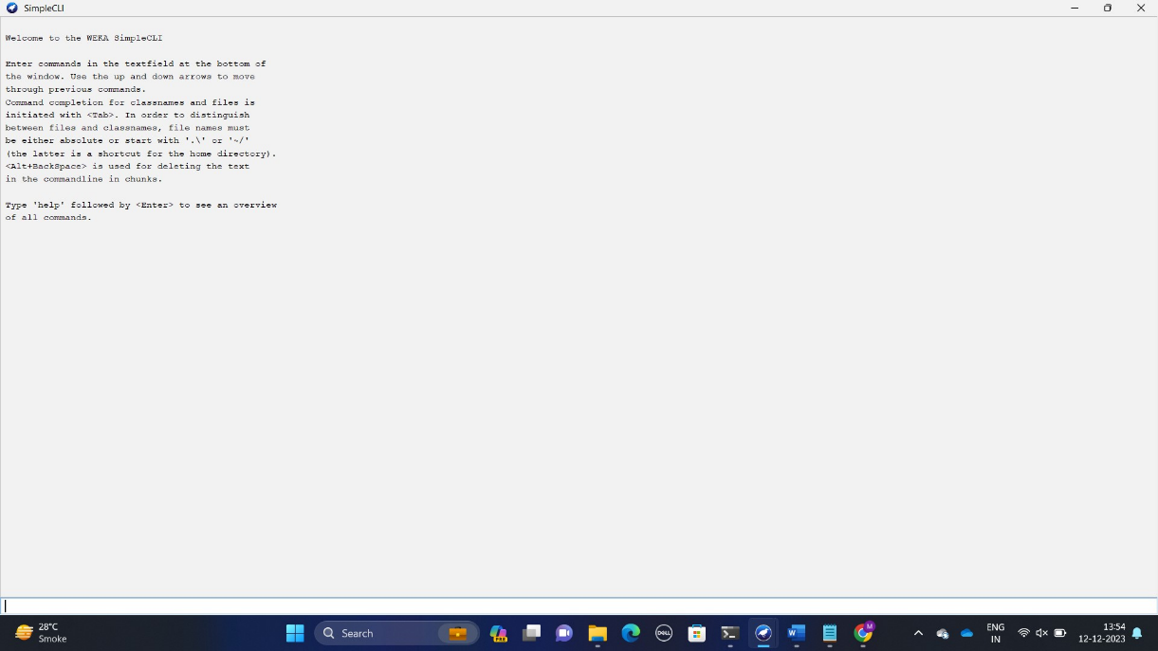

Figure 6:CLI menu

Step 6: Close the workbench and open experiment . Then go to open

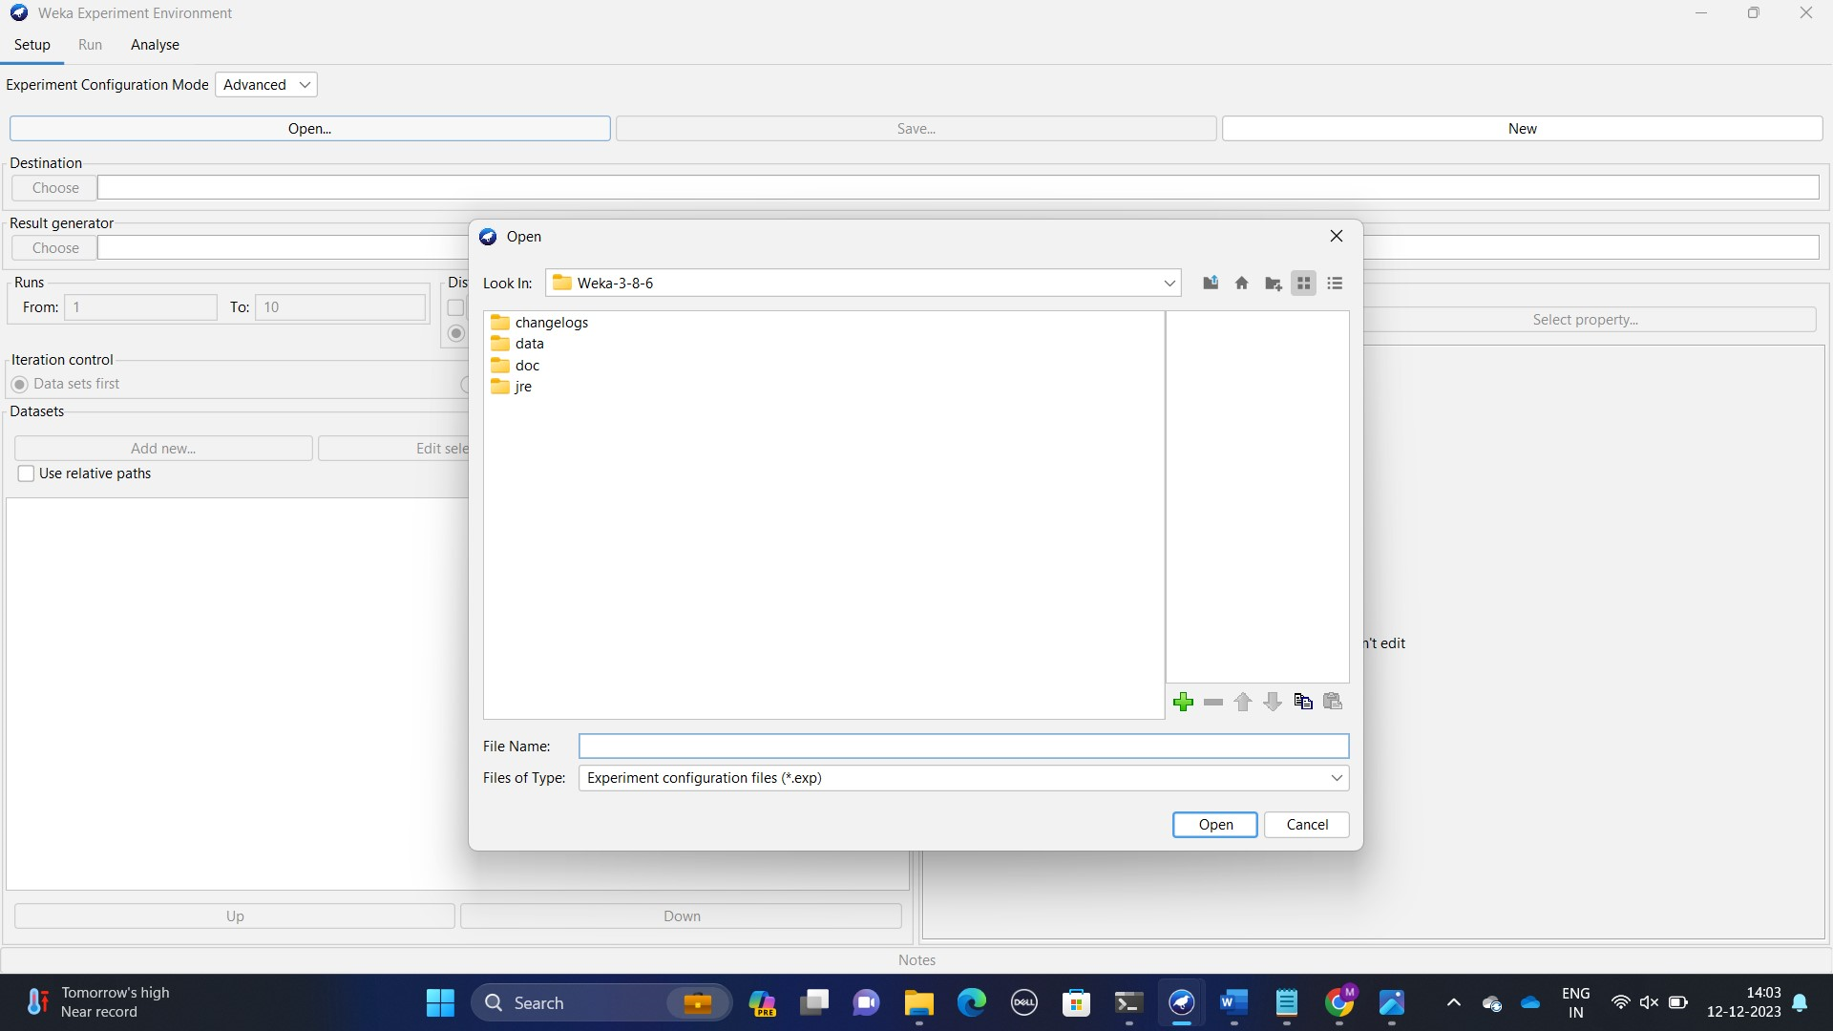

Figure 7: Figure of open file

Step 7: Experiment and go to new .

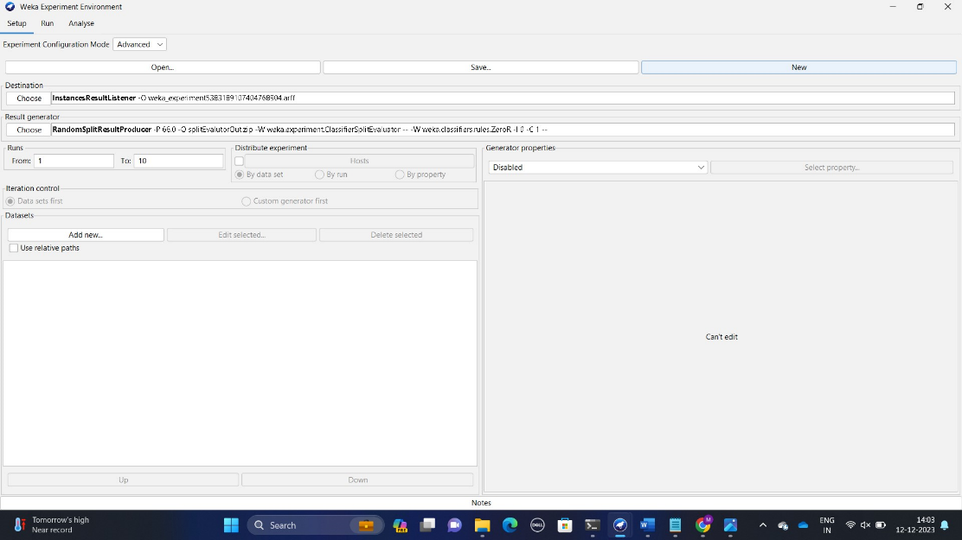

Figure 8: Figure of new

Step 8: Close experiment and open knowledge flow. Click on data mining processes.

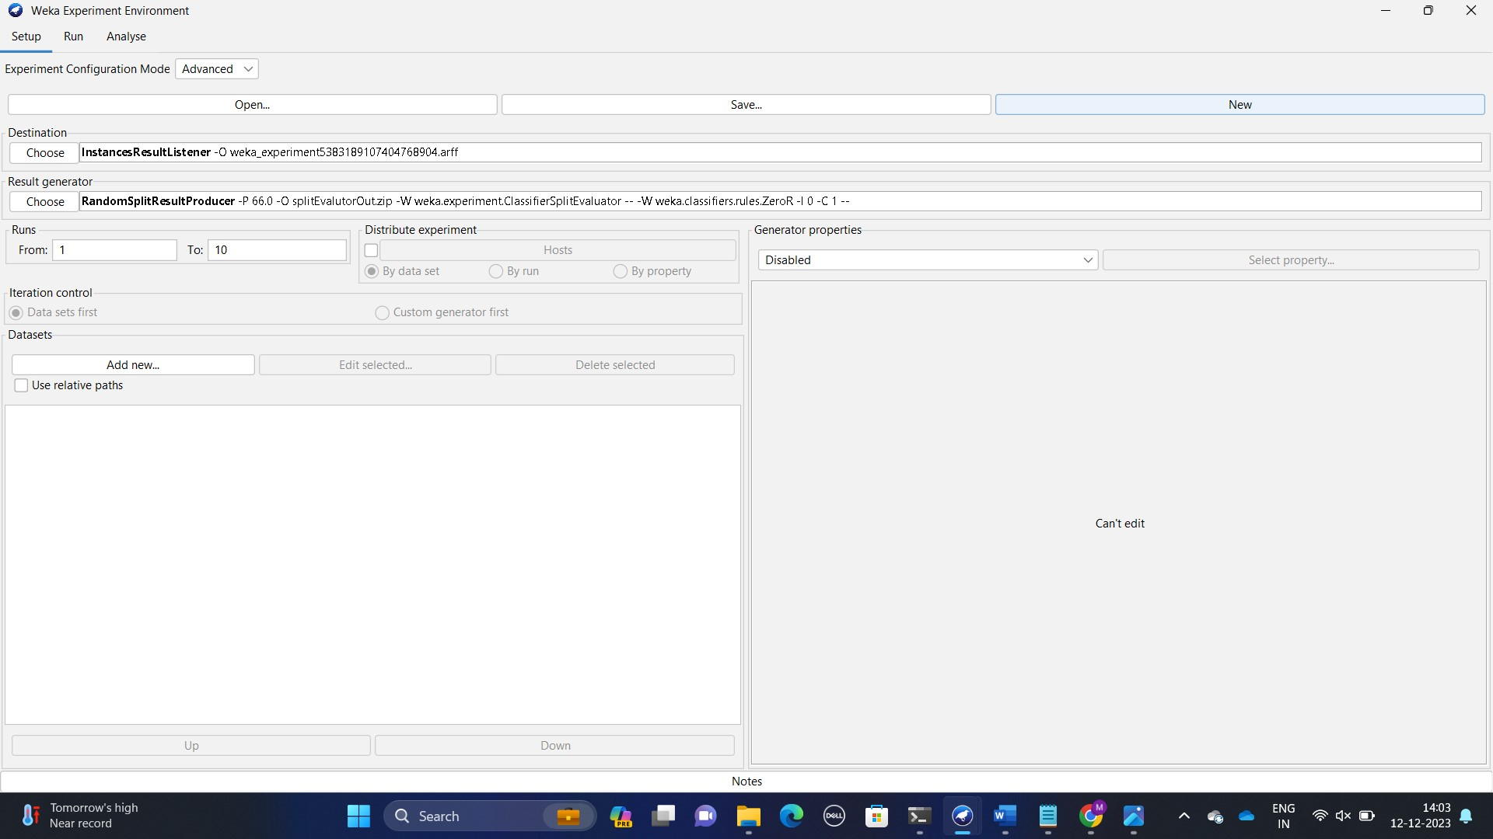

Figure 9:Data mining menu

Step 9: Close experiment and open workbench. Click on open file.

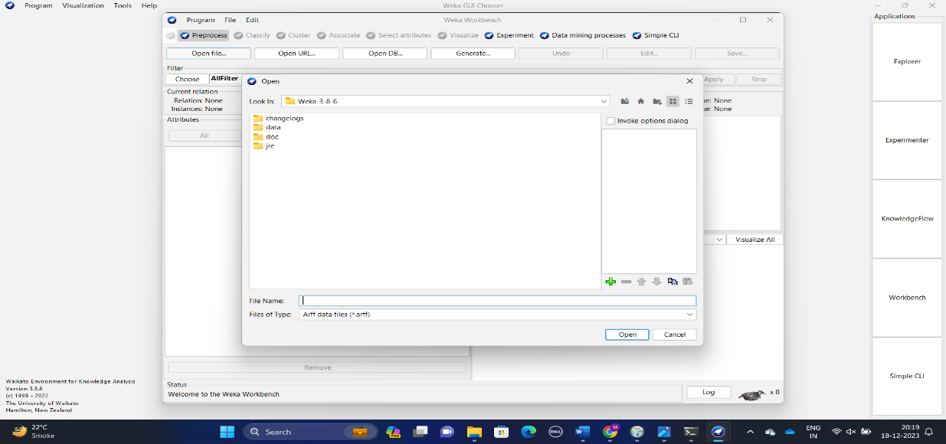

Figure 10:Figure of open file.

Step 10: Click on open url.

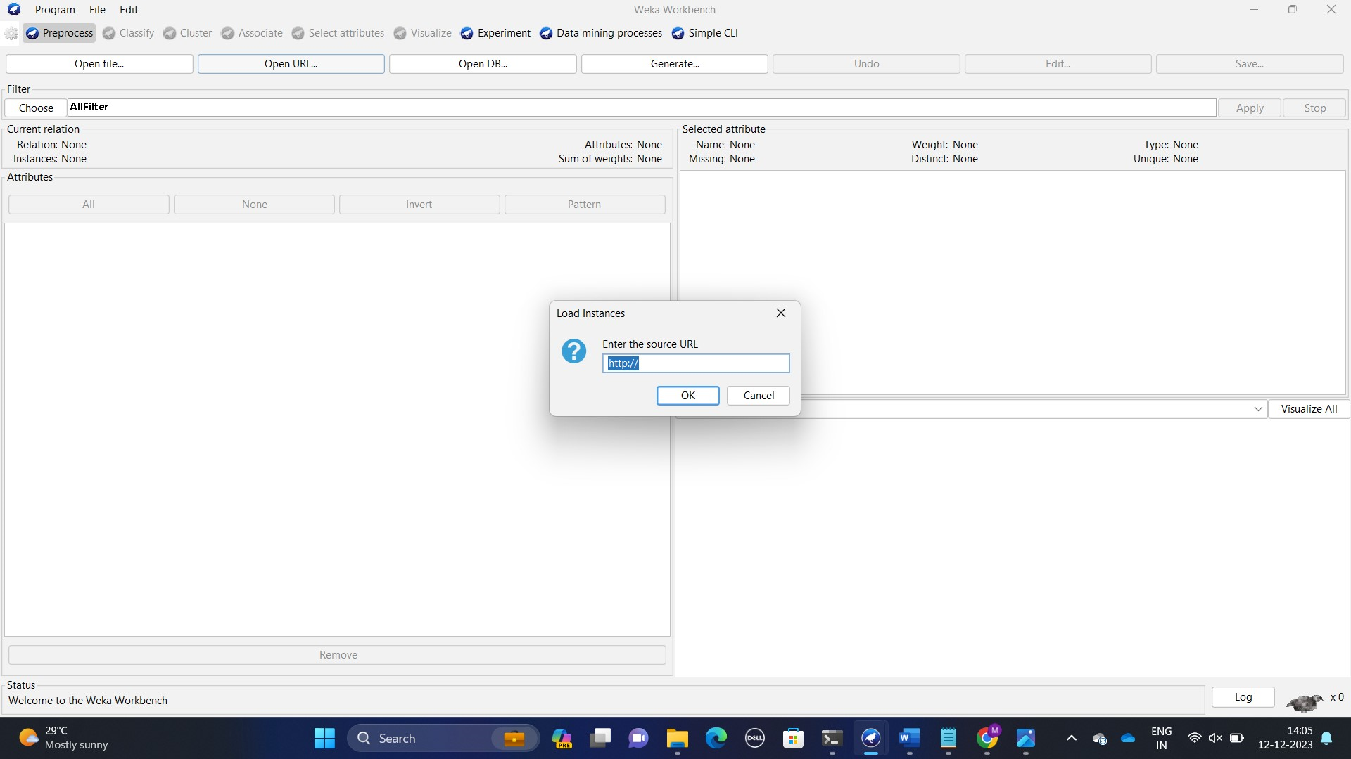

Figure 11: Url menu

Step 11: Click on open DB

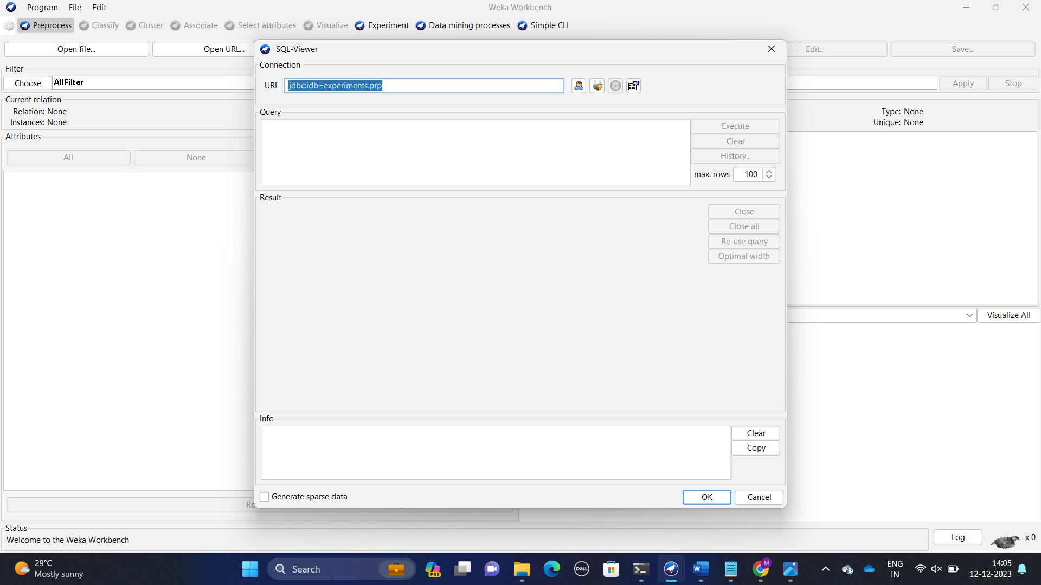

Figure 12:Database menu

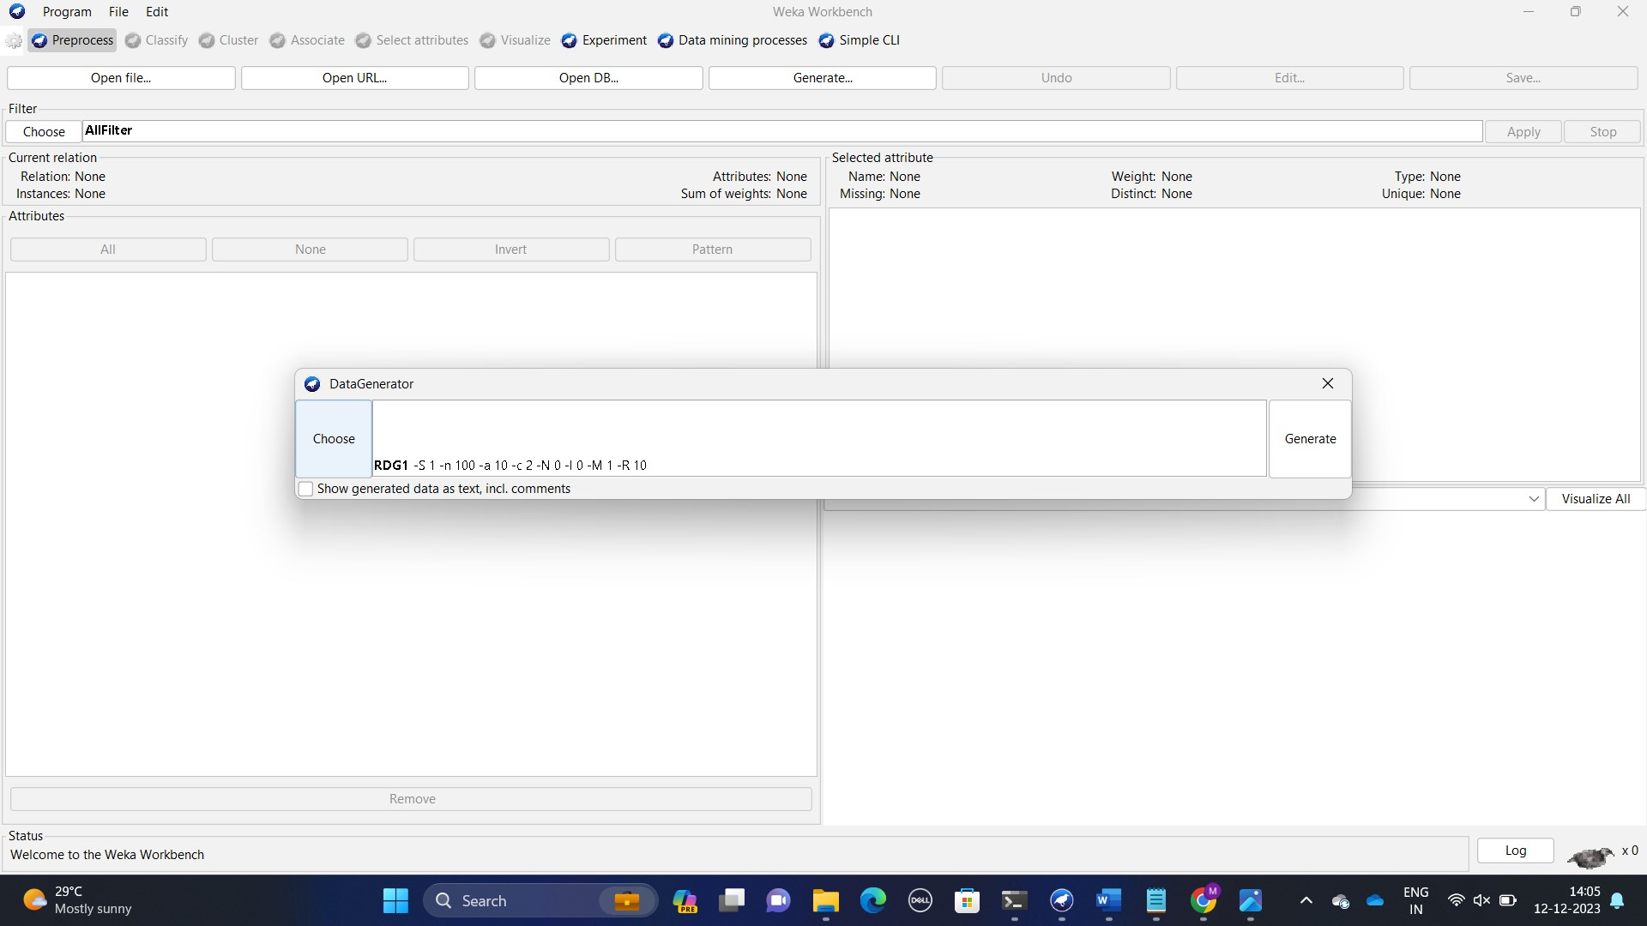Step 12: Click on generate

Figure 13:Generate menu

Step 13: Close workbench and open experiment. Change experiment configuration mode simple.

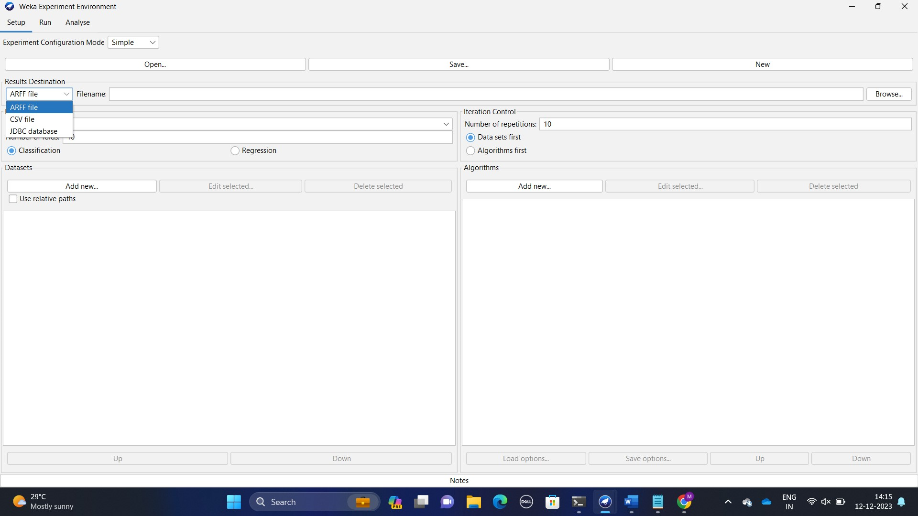

Figure 14:The simple mode configuration figure

Step 14:Go to program and open Arff viewer and then open file and from that open data

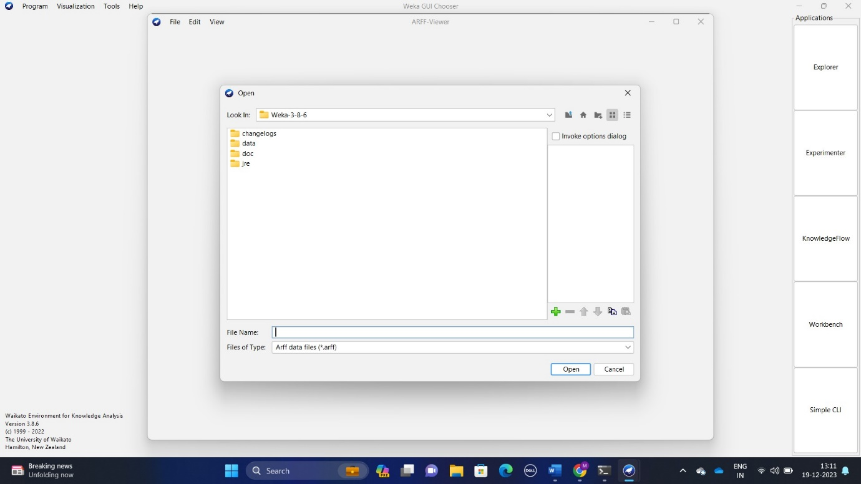

Figure 15:The figure of data menu

Step 15: From that go on data. It has collections of multiple data from that you can open any data set. We have opened weather numeric data.

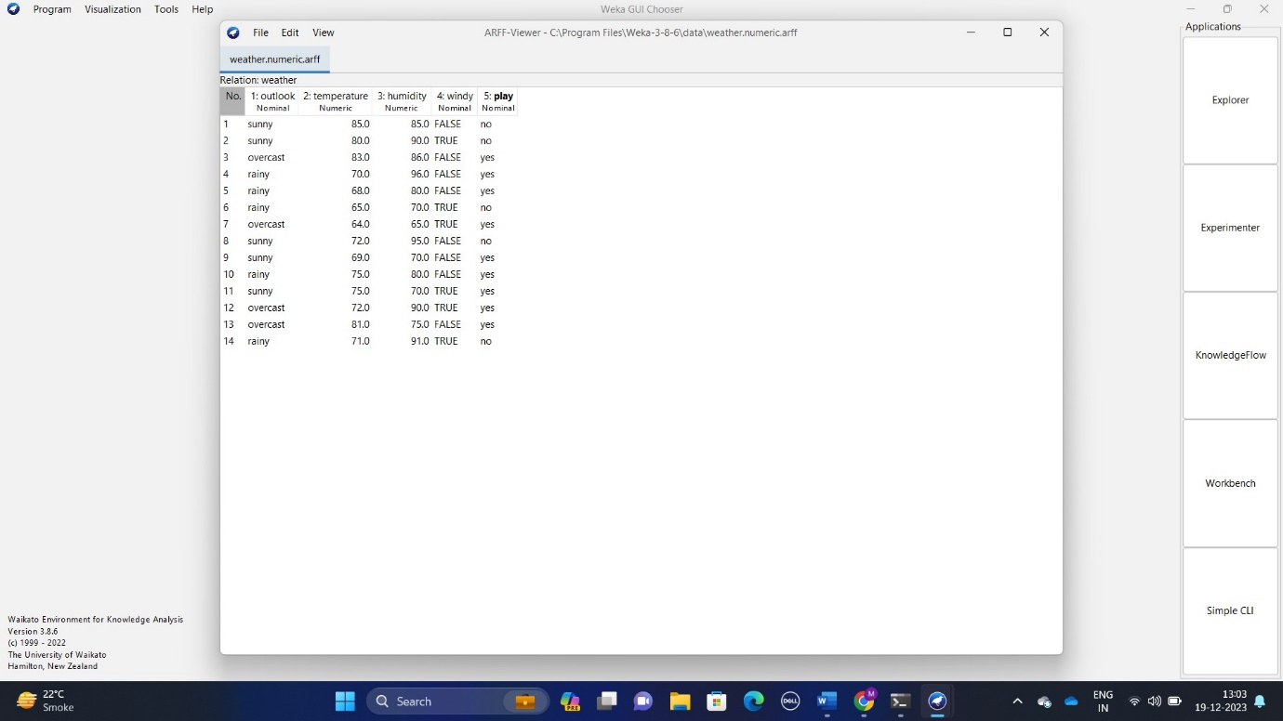

Figure 16:The figure of weather numeric data

**Advantages of Weka:**

* Testing new ideas quickly
* Easy to learn and solve data mining problems
* You can try different algorithms on your data set to quickly see which gives you the most accurate results.

**Disadvantages of Weka:**

* Some of the users are disappointed about the graphics quality.
* It can only handle small datasets.
* Alternative algorithms are not available.
* The user interface needs enhancement, and the designs and looks of the tool look old.

**PRACTICAL-2**

AIM:- Perform Pre-processing on a dataset using Weka Tool. Apply various Filters and discuss the effect of each filter applied.

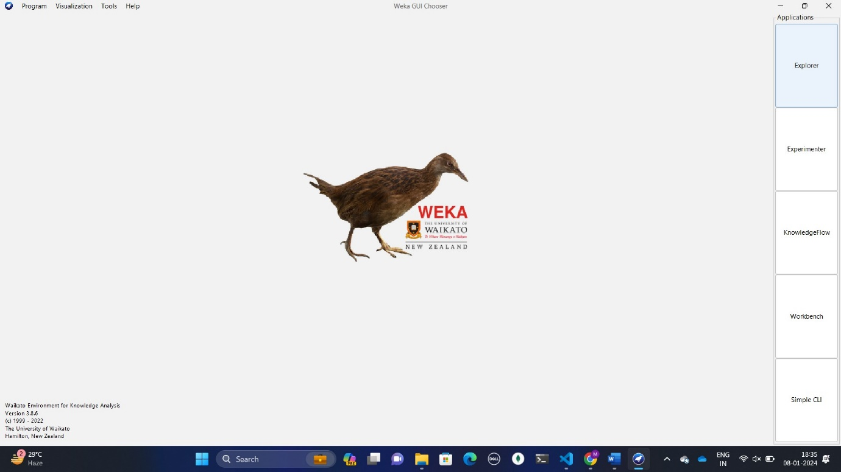**1)Handle Missing Values:**

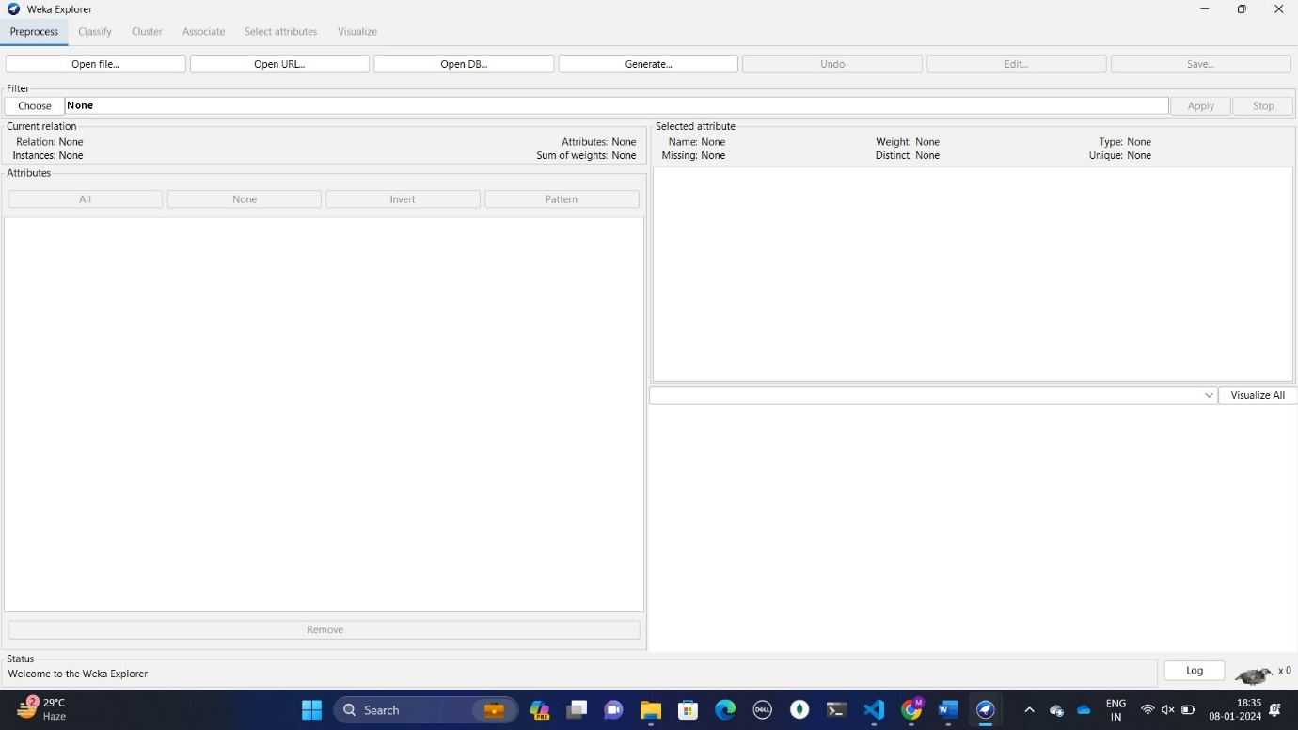

* + 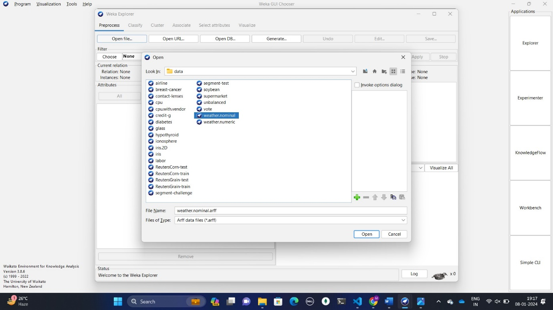Open Weka and click "Open file" to load your dataset.
  + Edit your database and remove some values from database.

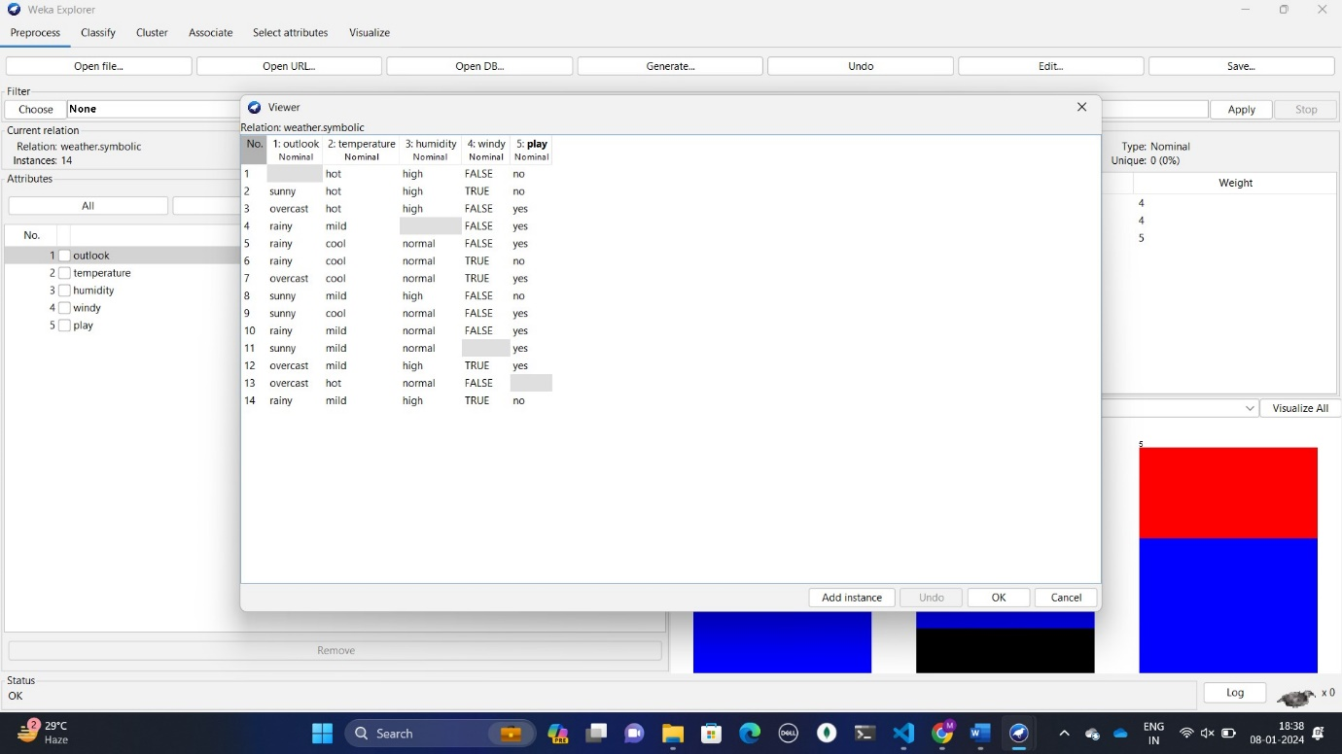

* Choose "Filters" > "Unsupervised" > "ReplaceMissingValues."

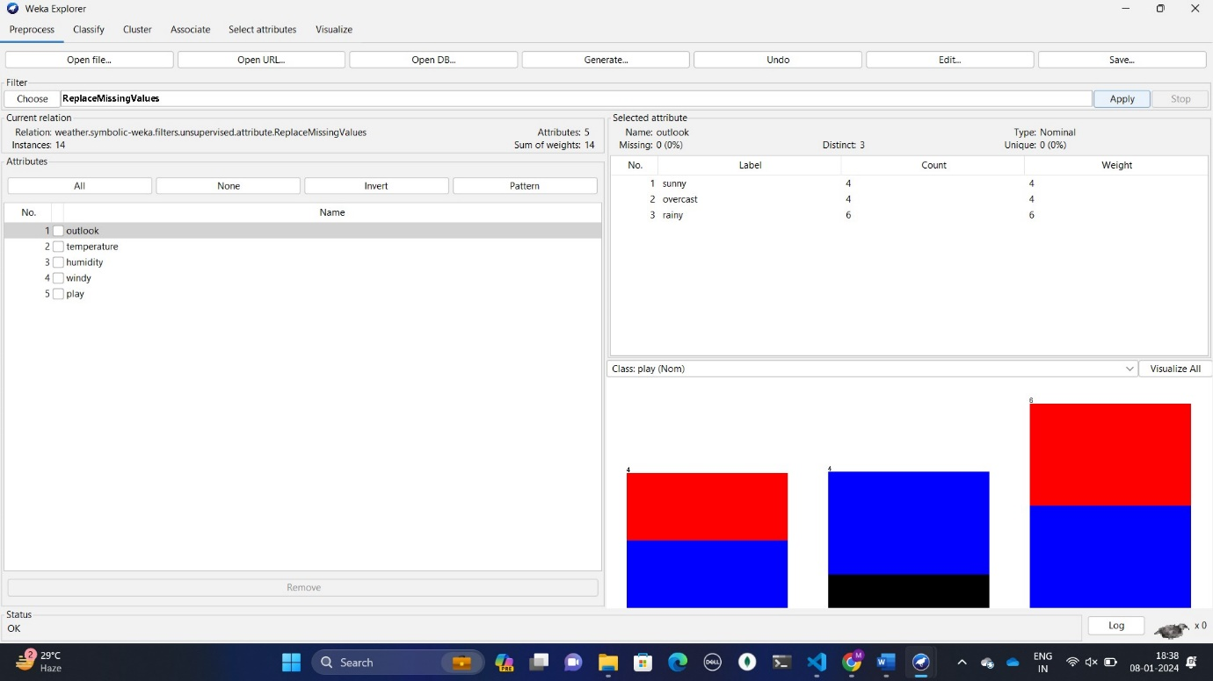

* + - Select a suitable imputation method based on data characteristics:
    - Mean: Replaces with the average of the feature.
    - Median: Replaces with the middle value.
    - Mode: Replaces with the most frequent value.
    - Effect: Ensures complete data for analysis and model training.

**Practical: 03**

**AIM:** **Perform Association rule mining using WEKA tool.**

**1] Introduction:**

Association rule mining finds interesting associations and relationships among large sets of data items. This

Rule shows how frequently item set occurs in a transaction. A typical example is a Market Based Analysis.

Market Based Analysis is one of the key techniques used by large relations to show associations between

Associations between items .It allows retailers to identify relationships between the items that people buy together frequently.

For example, the rule "If a customer buys bread, they are also likely to buy milk" is an association rule that could be mined from this data set.

**2] Loading data:**

Step 1: Open the Weka Tool.

Step 2: Click on Explorer. And then click on open file and select Local Disk(c :).

Step 3: Click on program files folder then open Weka folder and open data folder.

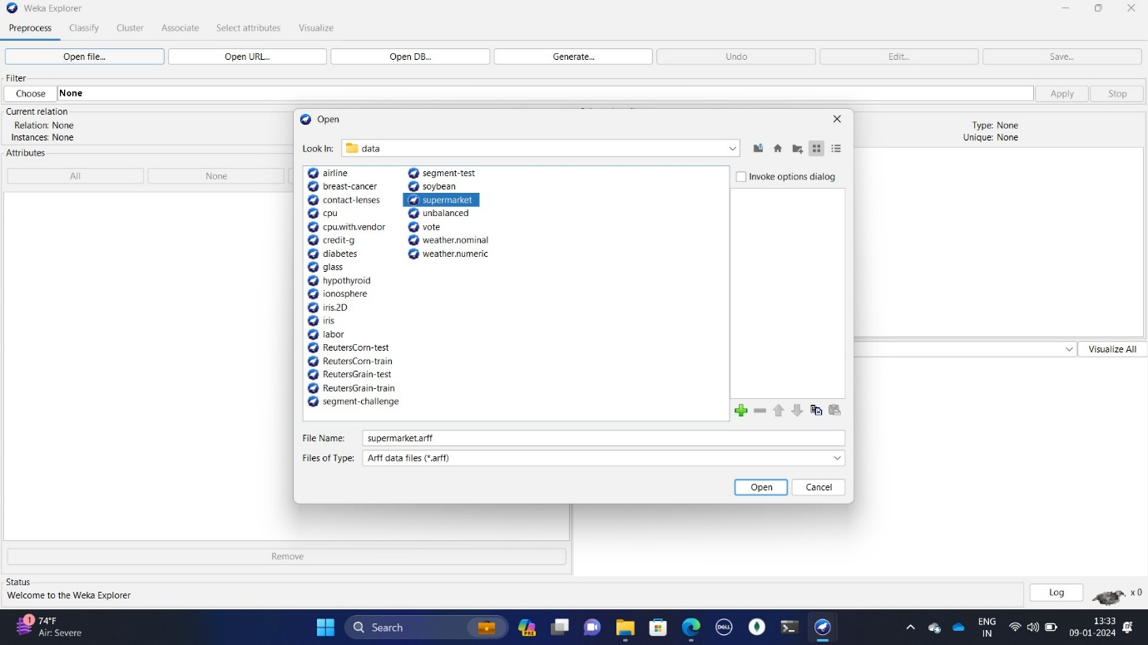 Step 4: select supermarket.arff database. AS shown in the following fig 2.1.

*Fig 2.1 Supermarket*

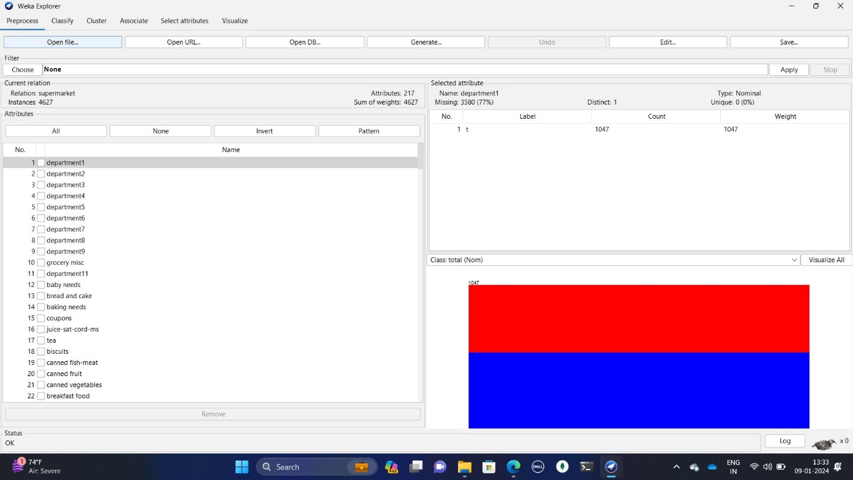Step 5:  After the data is loaded you will see the following fig 2.2

*Fig 2.2 Loading data*

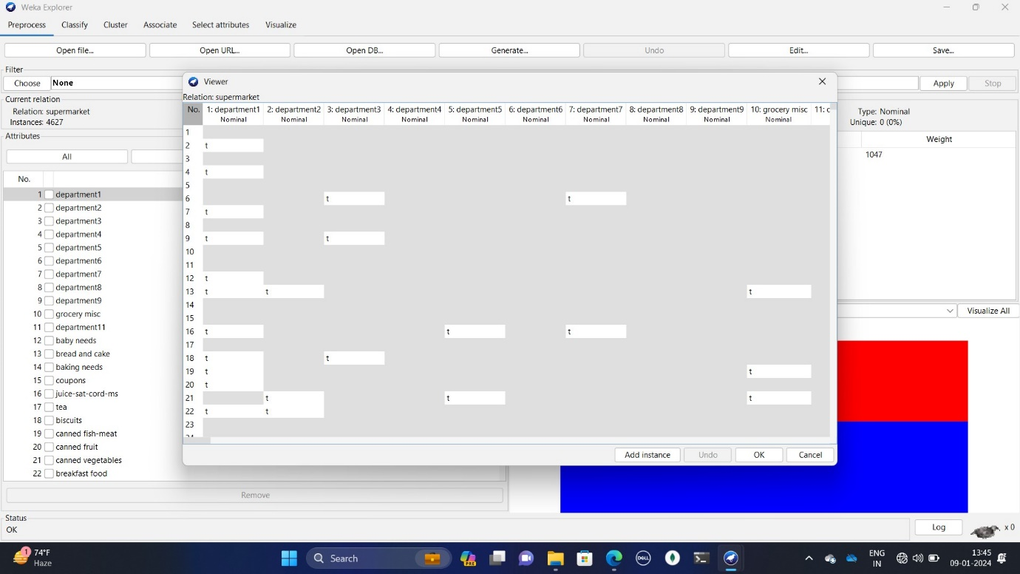Step 6: Click on department database table format and click on edit as shown in fig 2.3 it has 217 rows and 4623 column.

*Fig 2.3 database table format*

**3] Associate:**

**a) Apriori**: Apriori is an algorithm for frequent item set mining and association rule learning over relational Database.

Step 1: Click on the Associate TAB and click on the Choose button. Select the Apriori association.

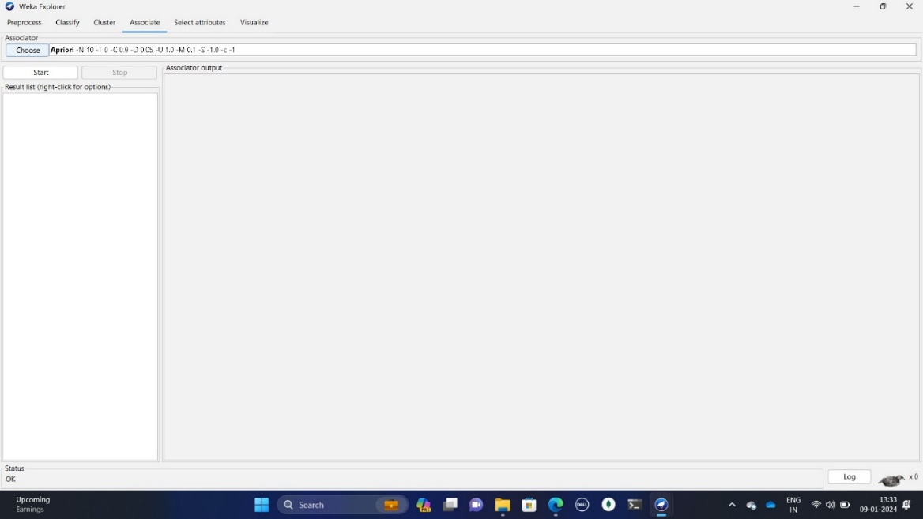 In fig. 3.1.

*Fig 3.1 Apriori*

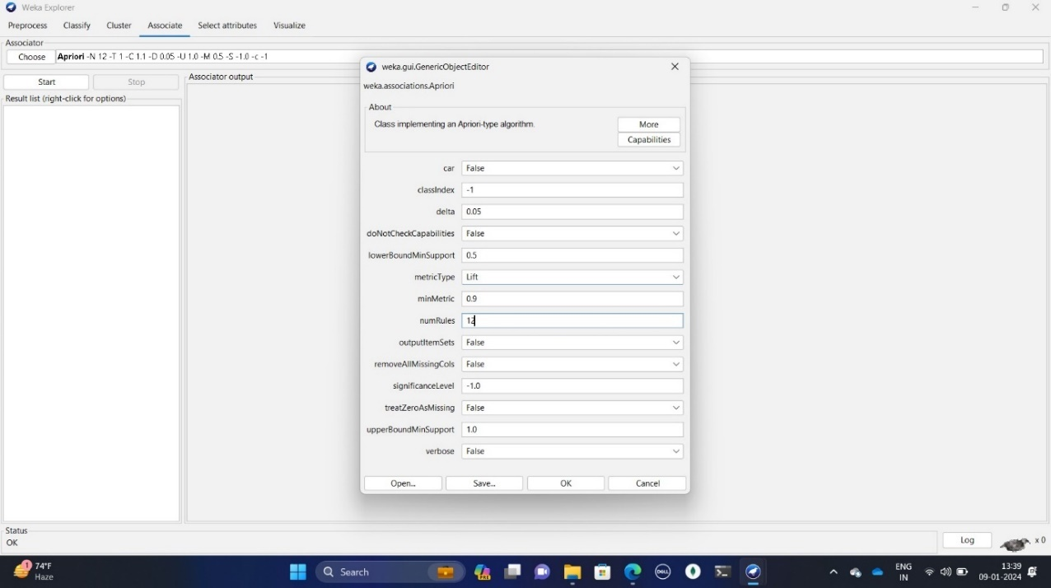Step 2: click on Apriori a new window will open as show in fig 3.2 and change a numrules

*Fig 3.2 editing value*

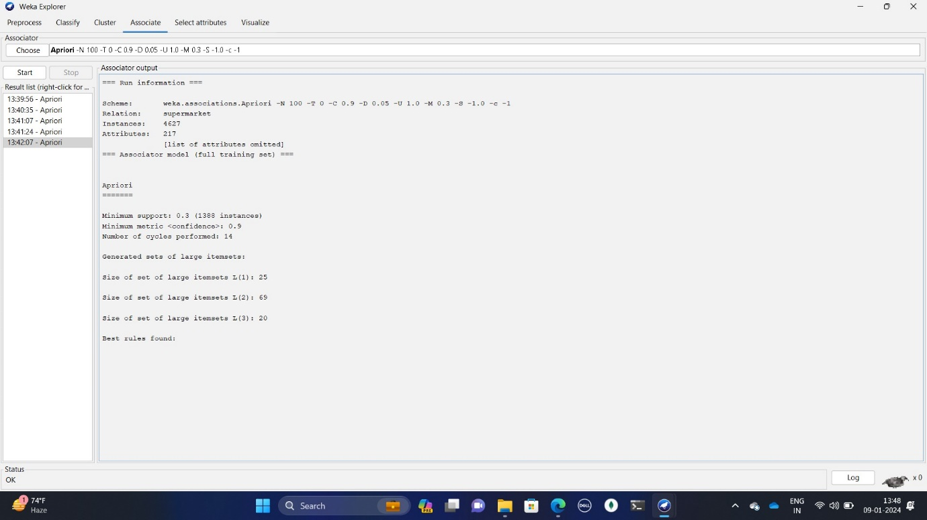Step 3: After changing a rules values then click on ok, as shown in fig 3.3.

*Fig 3.3 apriori output*

**b) Filterassociator:** The Filter Associator algorithm is a variant of the **Apriori algorithm**. It uses a filtering

Technique to reduce the number of candidate item sets generated by the algorithm.

Step 1: Click on the Associate TAB and click on the Choose button. Select the filterassociator association as

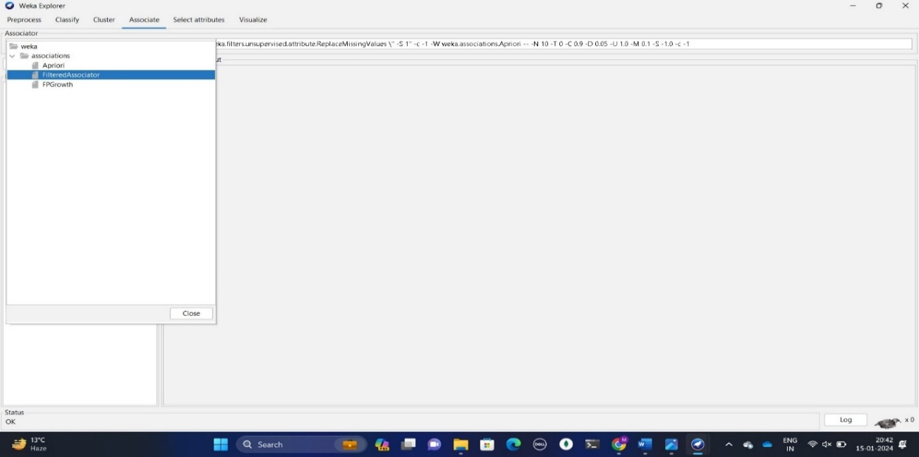 Show in fig 3.4

*Fig 3.4 select filterassociator*

Step 2: click on filterassociator a new window will open as show in fig 3.5.

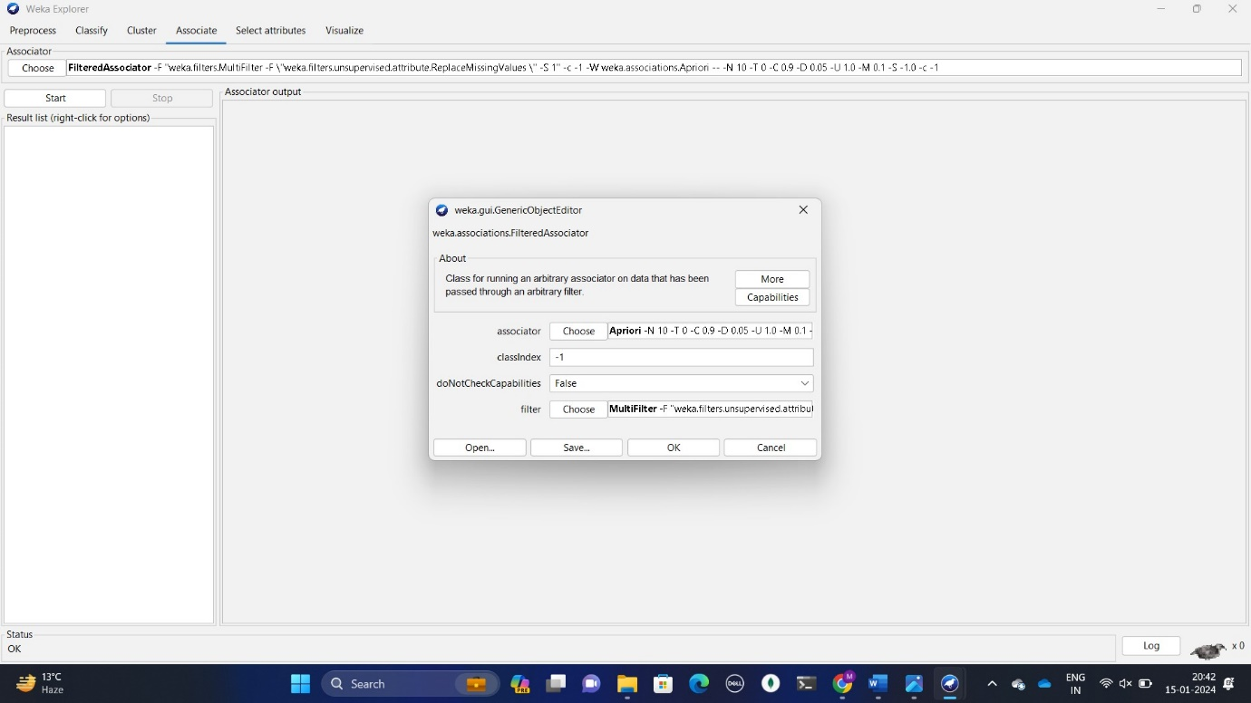*Fig 3.5 editing value*

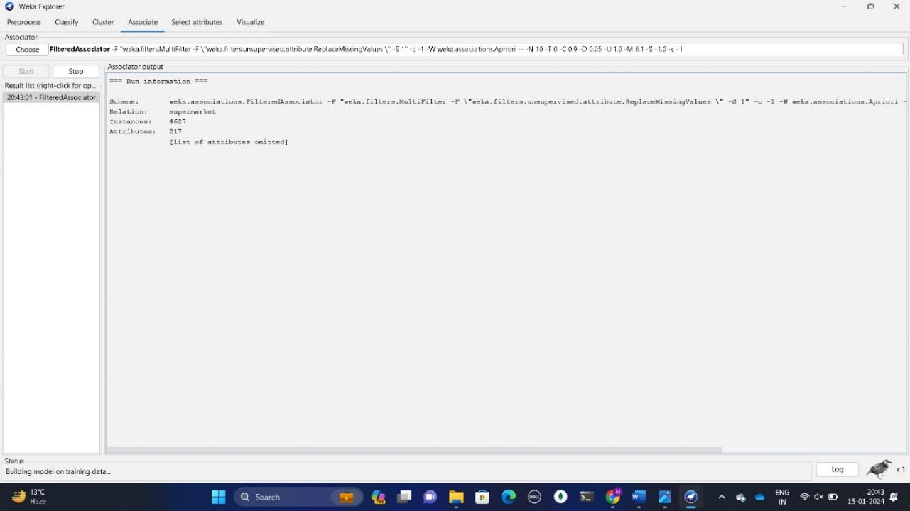Step 3: After changing a rules values then click on ok, as show in fig 3.6

*Fig 3.6 filteredassociator output*

**c) FPGrowth:** The FP-Growth Algorithm is an alternative way to find frequent item sets without using candidate generations, thus improving performance. For so much, it uses a divide-and-conquer strategy. The core of this method is the usage of a special data structure named frequent-pattern tree (FP-tree), which retains the item set association information.

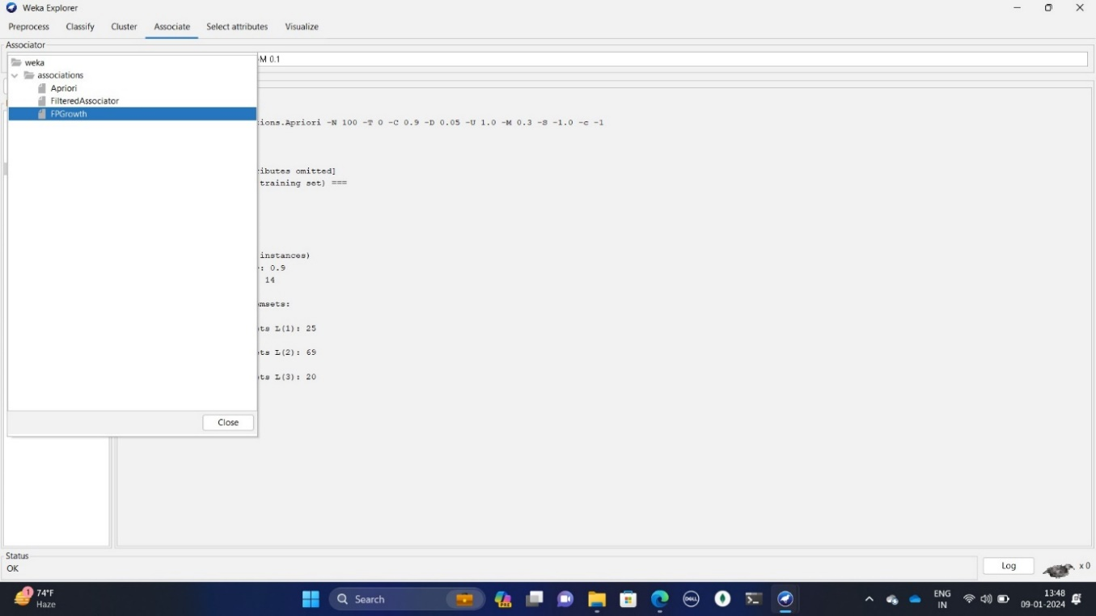Step 1: Click on the Associate TAB and click on the Choose button. Select the FPGrowth association Shown in fig. 3.7

*Fig 3.7 select FPGrowth*

Step 2: click on FPGrowth a new window will open as show in fig 3.8

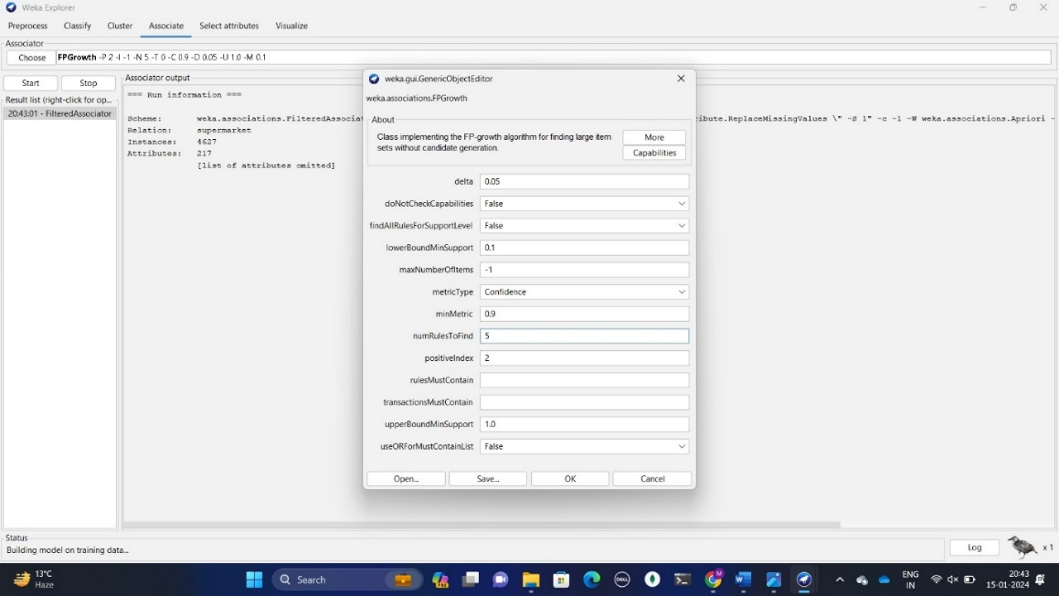

*Fig 3.8 editing values*

Step 3: After changing a rules values then click on ok, as show in fig

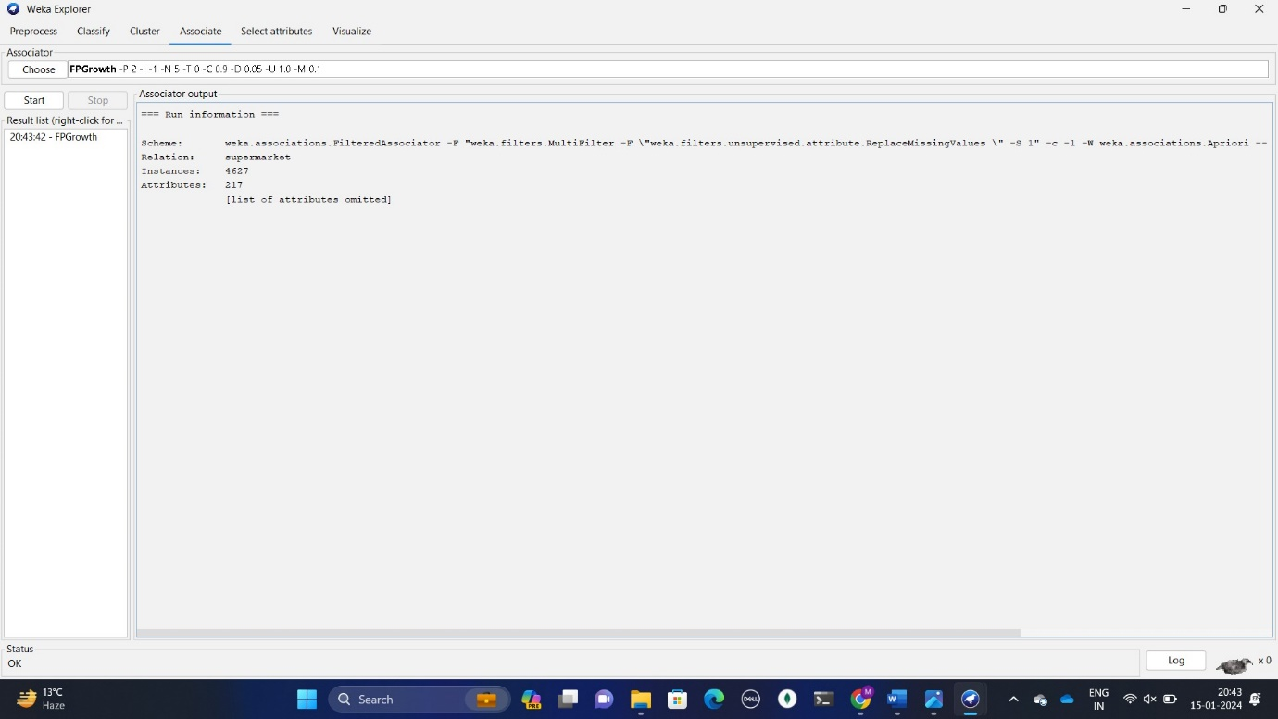*Fig 3.9 FP Growth output*

**4] Conclusion:**

In this practical, we learn about the introduction of association rule mining, and how to find apriori rules and Filteredassociator rules and FPGrowth rules.

**Practical :04**

**Aim:** Perform Classification with WEKA tool.

**1] Theory:**

Classification is to identify the category or the class label of a new observation. First, a set of data is used as training data. The set of input data and the corresponding outputs are given to the algorithm. So, the training data set includes the input data and their associated class labels.

Using the training dataset, the algorithm derives a model or the classifier. The derived model can be a decision tree, mathematical formula, or a neural network.

In classification, when unlabelled data is given to the model, it should find the class to which it belongs. The new data provided to the model is the test data set.

Classification is the process of classifying a record. One simple example of classification is to check whether it is raining or not. The answer can either be yes or no. So, there is a particular number of choices. Sometimes there can be more than two classes to classify. That is called multiclass classification.

**2]Load the data:**

Step 1: Open the Weka Tool.

Step 2: Click on Explorer. And then click on open file and select Local Disk(c :).

Step 3: Click on program files folder then open Weka folder and open data folder.

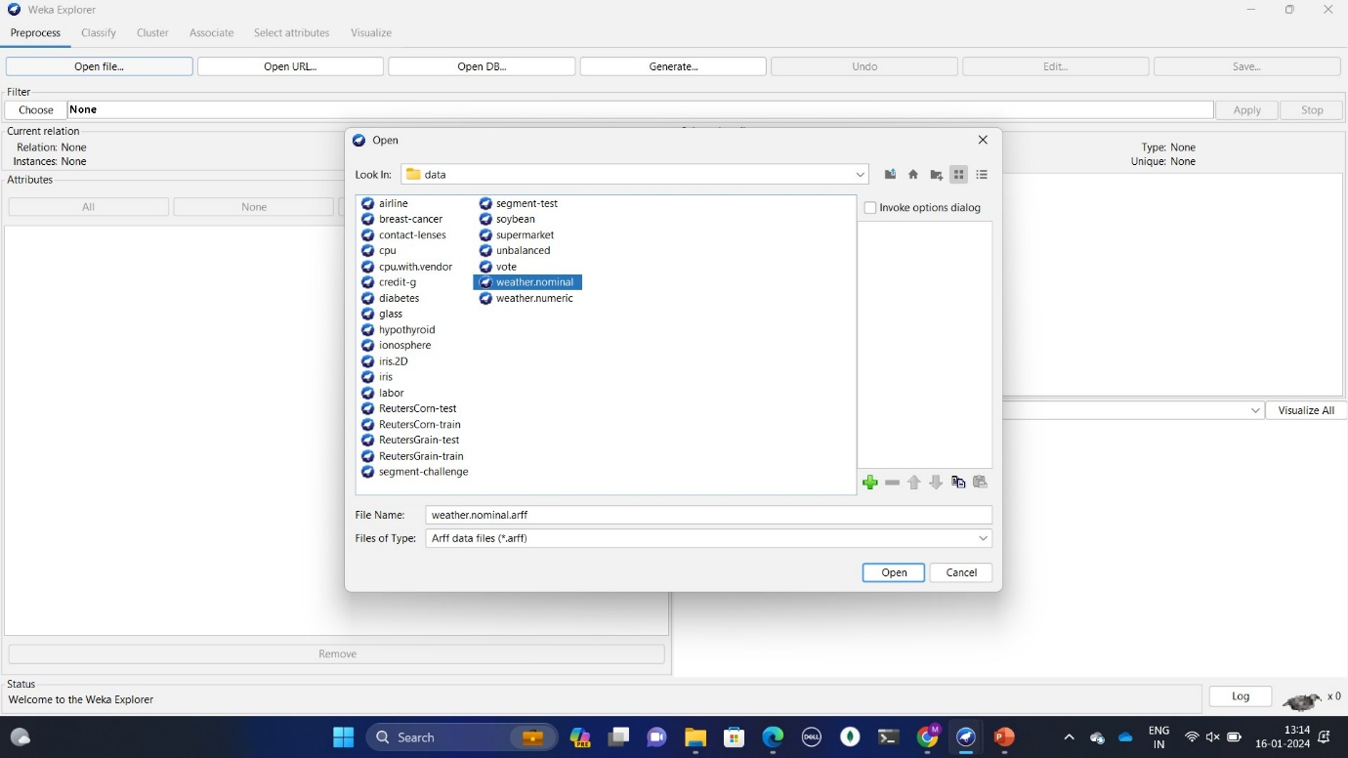 Step 4: select weather.nominal database. As shown in the following fig 2.1.

*Figure2.1 weathernominaldata*

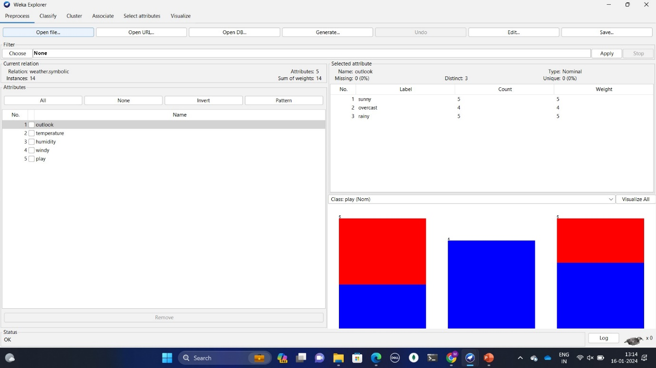Step 5: After the data is loaded you will see the following fig 2.2

*Figure 2.2 The data is loaded*

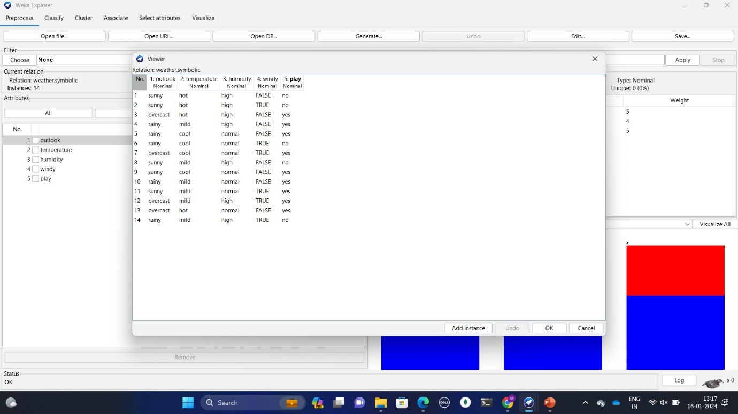Step 6: Click on department database table format and click on edit as shown in fig 2.3 it has 14 rows and 5 column.

*Figure 2.3 The data is loaded*

**3] Classify:**

**A]J48 filter:**

Step 1: Click on the Classify TAB and click on the Choose button. Select the filter J48.

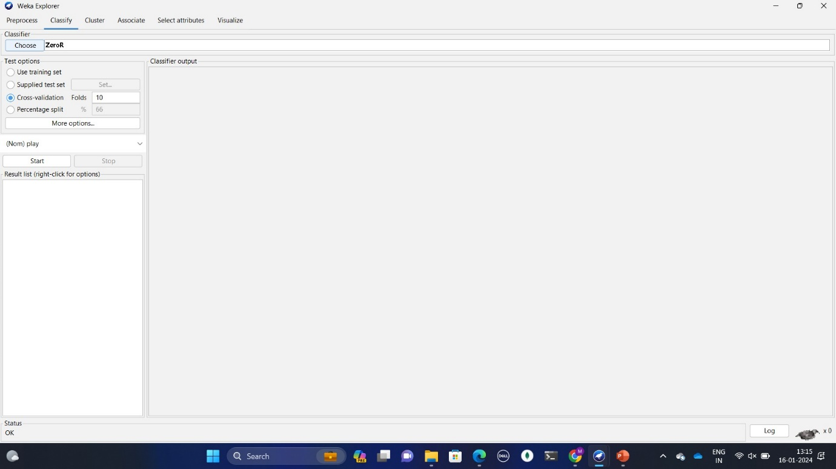 In fig. 3.1

*Figure3.1 Classify tab*

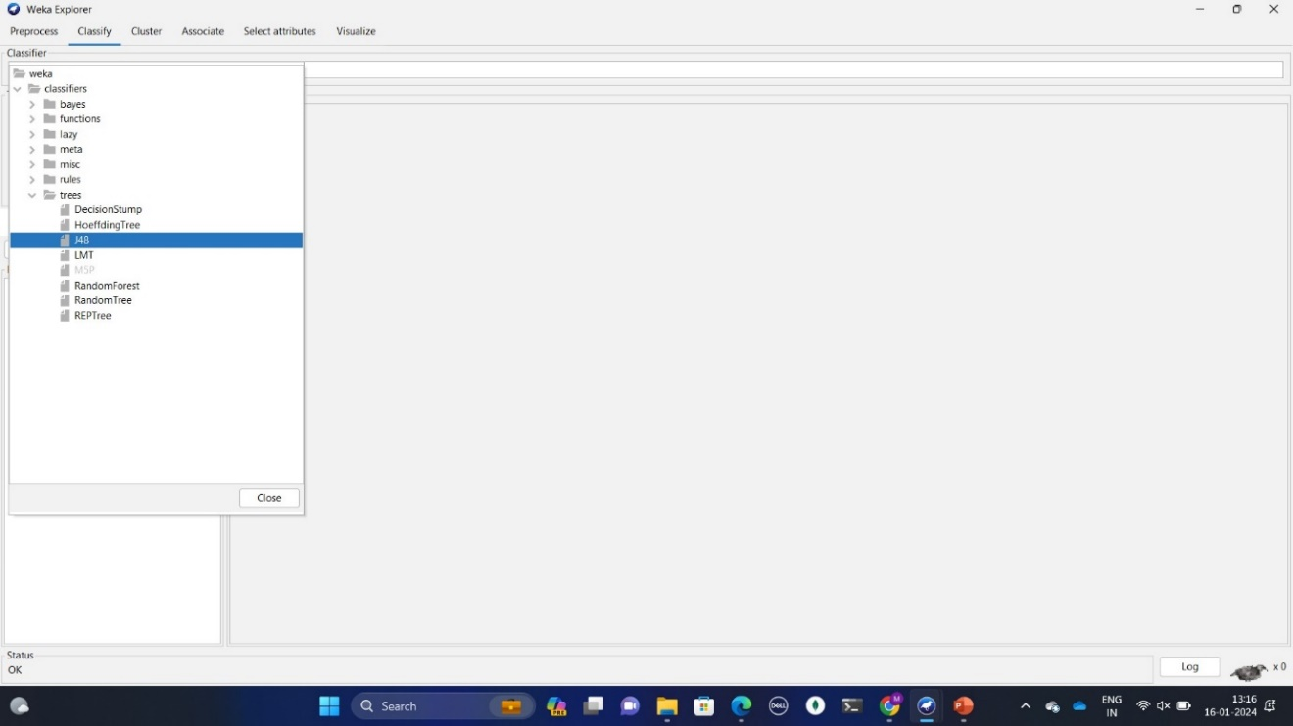Step 2: click on J48 filter and give percentage split 80%

*Figure 3.2 J48 filter figure*

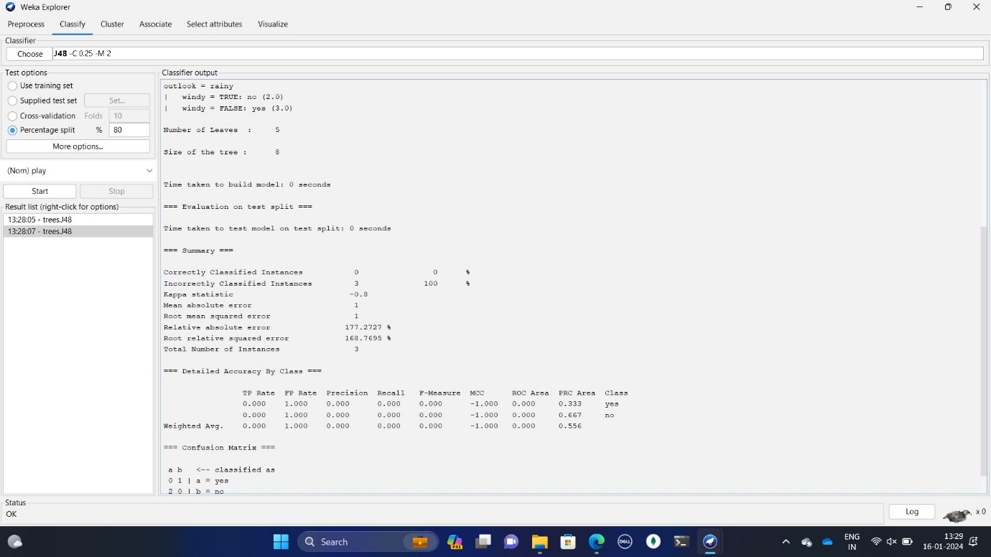Step 3:The output is shown in following figures.

*Figure 3.3 Output figure*

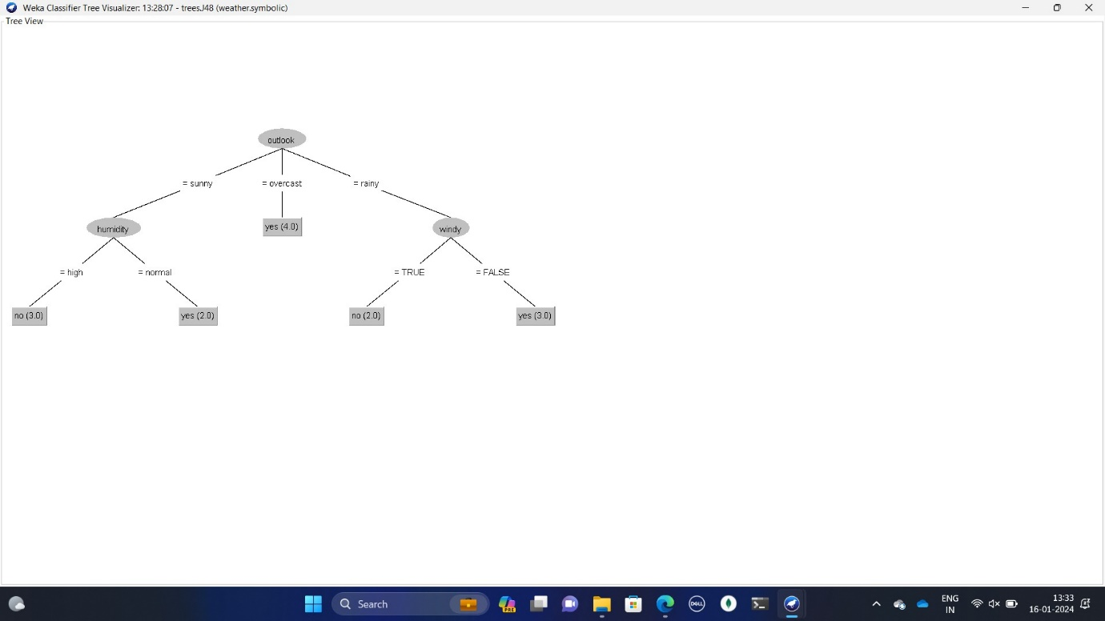Step 4:The output in tree form

*Figure 3.4 Tree figure*

**B]BayesNet::**

Step 1: Click on the Classify TAB and click on the Choose button. Select the filter Bayes and inside it select BayesNet filter

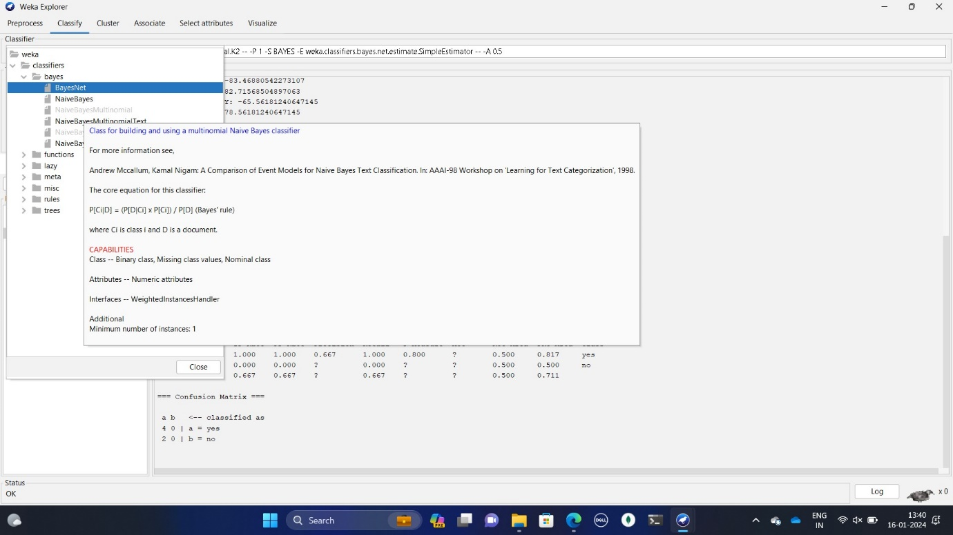*Figure 3.5 BayesNet filter figure*

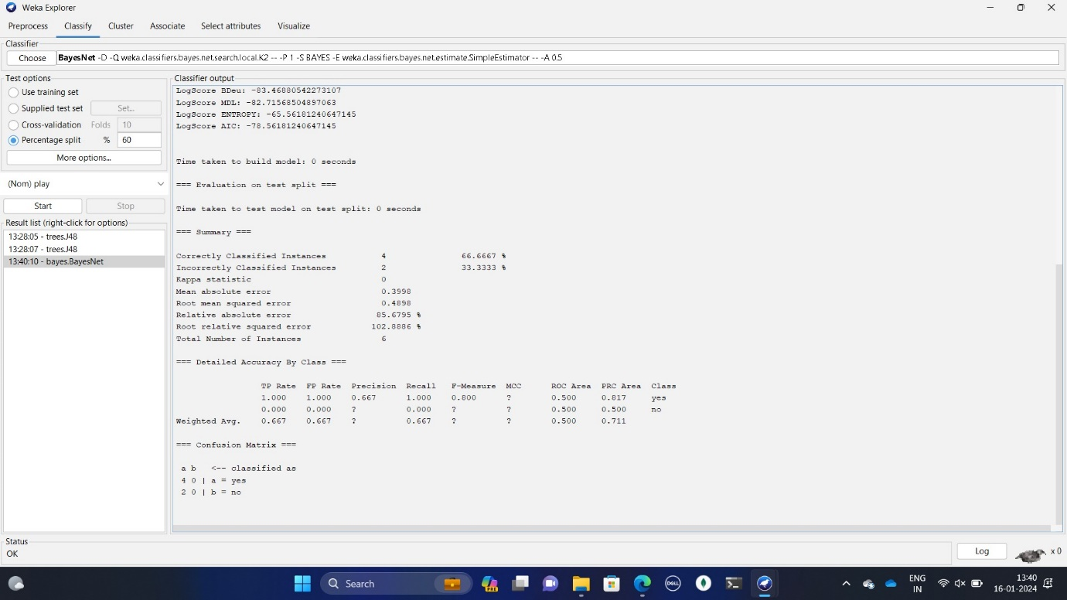Step 2:After selecting give percentage 60%

*Figure 3.6 Percentage spilt figure*

 Step 3: The output is shown in the following figure.

Figure 3.7 Output figure

Step 4: The graph of output is shown.

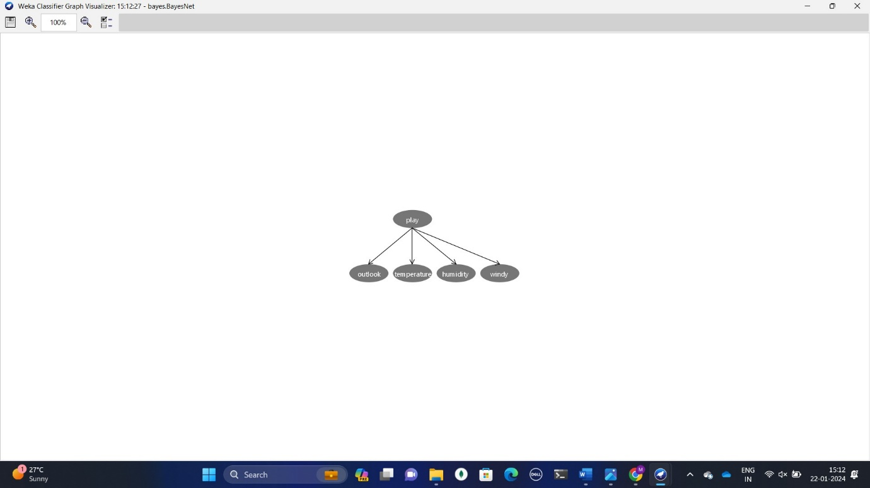

Figure 3.8 Graph figure

**C] Logistics:**

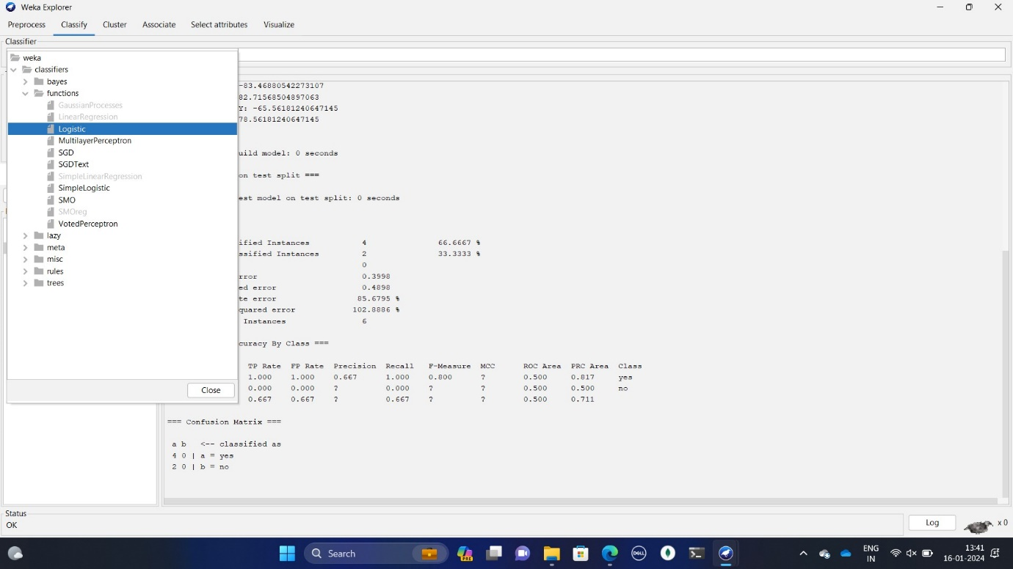Step 1: Click on the Classify TAB and click on the Choose button. Select the function filter and inside that logistic filter

Figure 3.9 Logistics filter

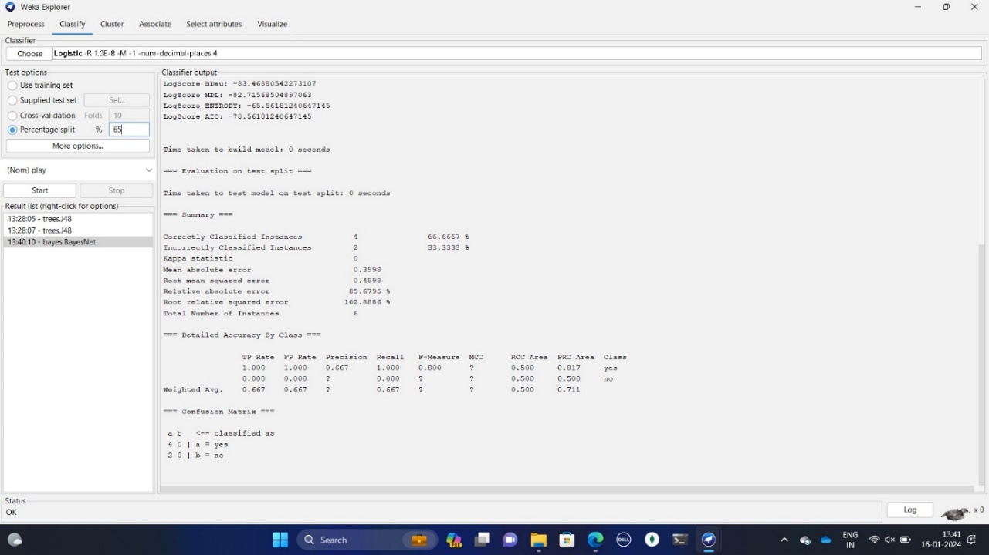Step 2: Select the percentage spilt 65%

Figure 3.10 Percentage spilt

Step 3: The output is shown in the following figure

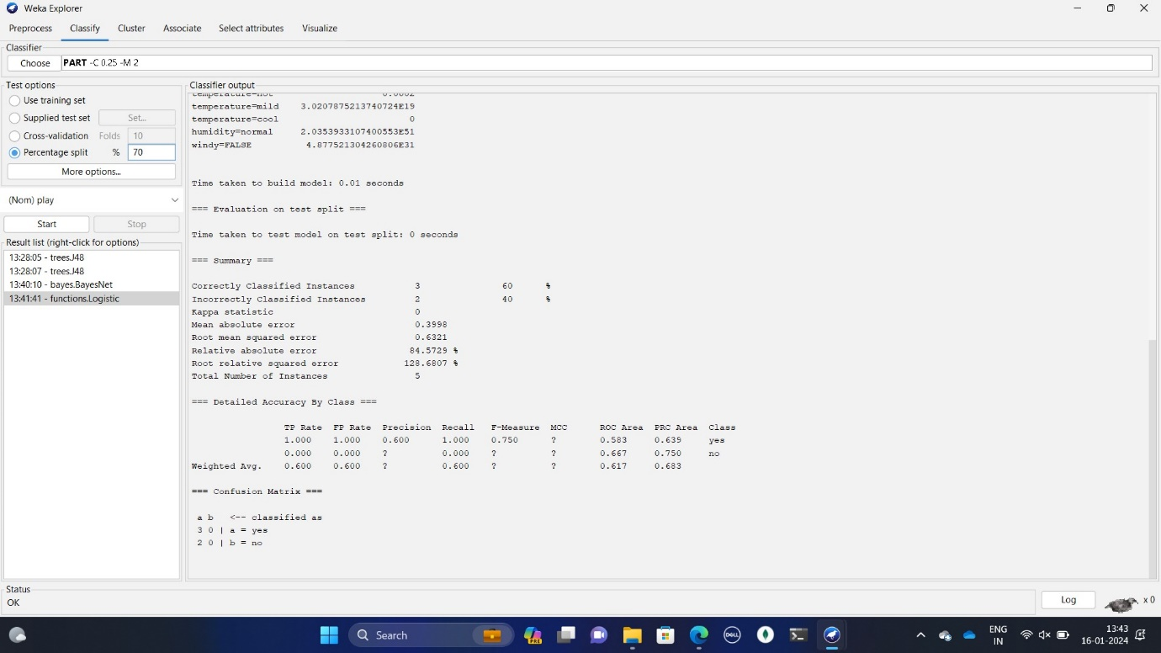Figure 3.11 Output figure

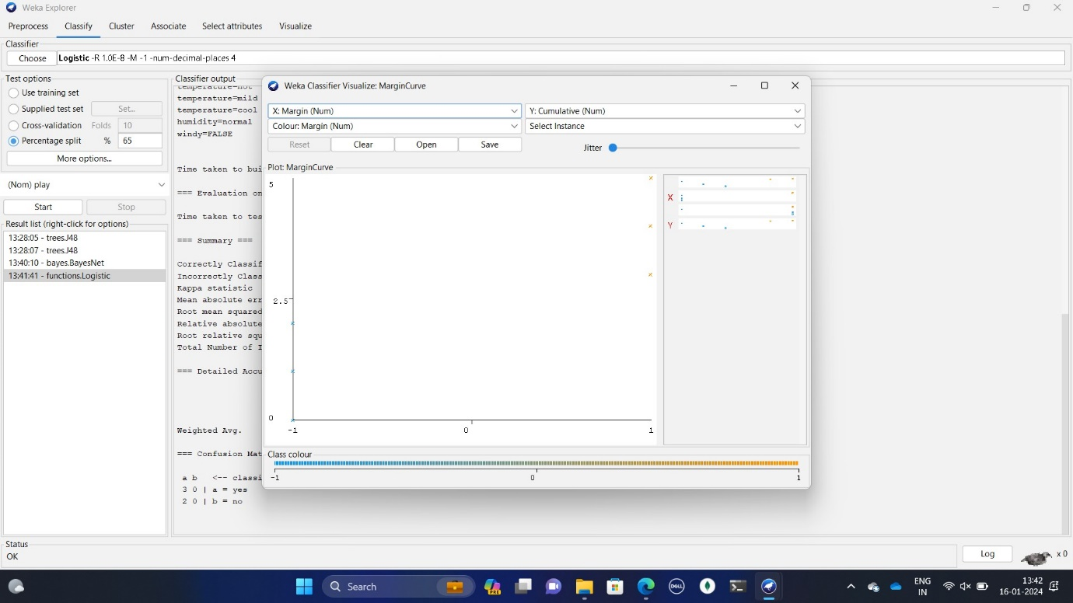Step 4:The margin curve pf output is shown in the following .

Figure 3.12 Margin curve figure

**D] PART:**

Step 1: Click on the Classify TAB and click on the Choose button. Select the rules filter and inside that select PART filter

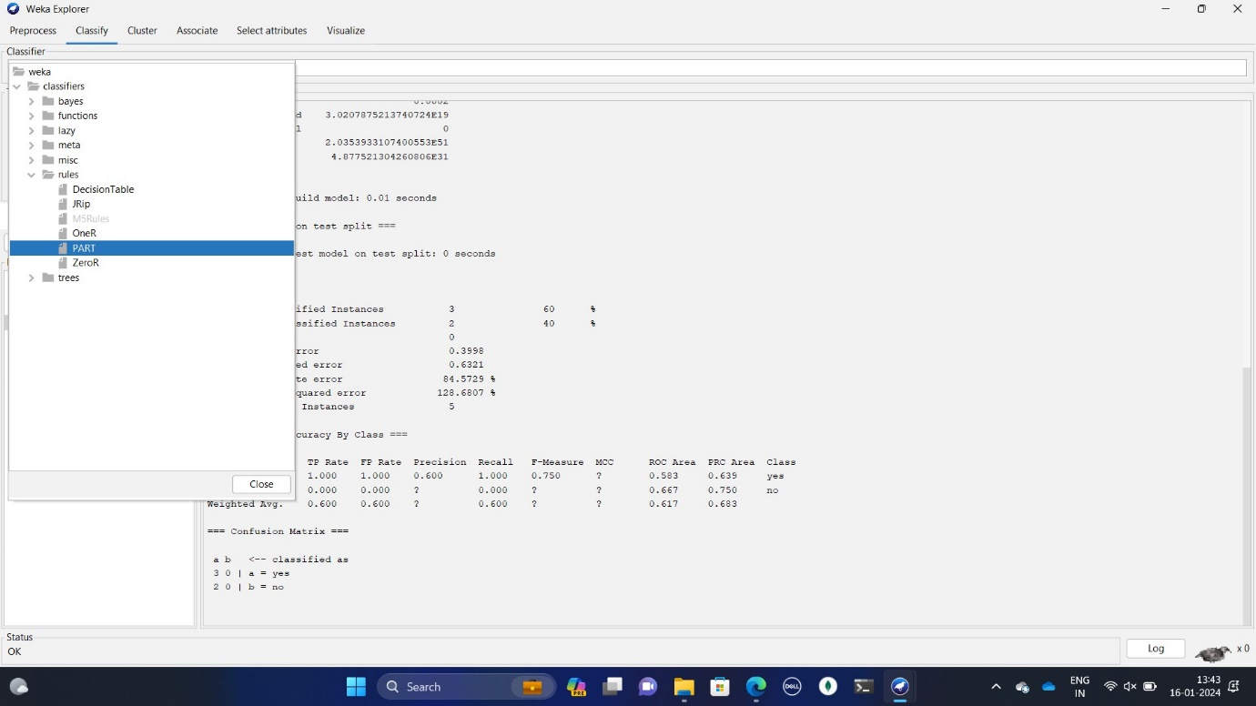Figure 3.13 PART filter figure

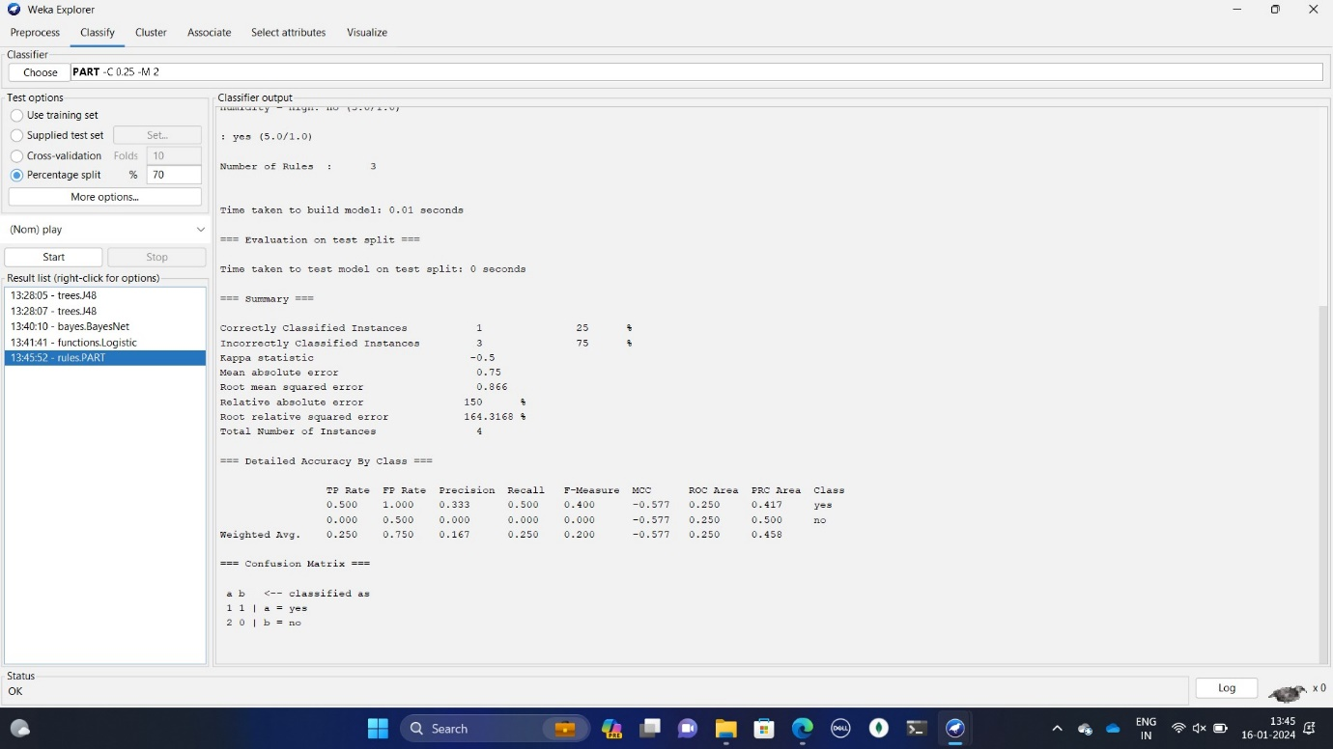Step 2: Select the percentage spilt 70%

Figure 3.14 Percentage spilt figure

Step 3: The output is shown in the following figure.



Figure 3.15 Output figure

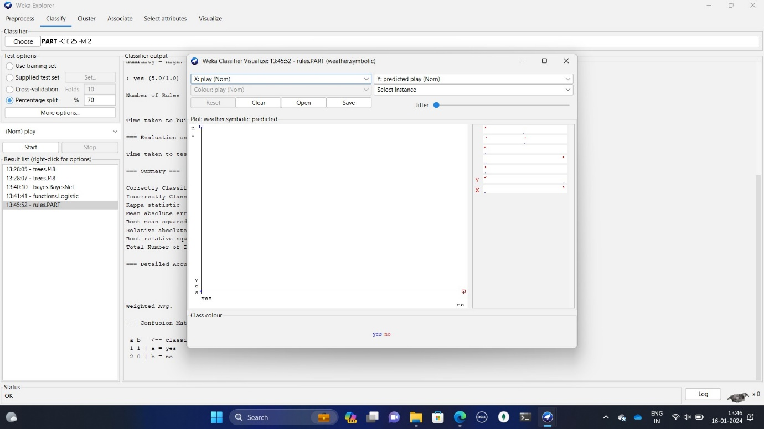Step 4: The Margin curve of output is shown in the following.

Figure 3.16 Margin curve figure

|  |  |  |  |  |
| --- | --- | --- | --- | --- |
| Classify | 80-20 | 70-30 | 60-40 | Best case |
| J48 | 0 | 25 | 50 | 60-40 |
| BayesNet | 33.33 | 50 | 66.6667 | 60-40 |

**4]Conclusion** :

In this practical, we learn about the introduction of classification in data mining, and how to find correct instance with percentage spilt that gives correct accuracy

**Practical : 05**

**Aim:** Perform Clustering with Weka tool

Theory:

* Clustering is the method of converting a group of abstract objects into classes of similar objects.
* Clustering is a method of partitioning a set of data or objects into a set of significant subclasses called clusters.
* It helps users to understand the structure or natural grouping in a data set and used either as a stand-alone instrument to get a better insight into data distribution or as a pre-processing step for other algorithms
* Data objects of a cluster can be considered as one group.
* We first partition the information set into groups while doing cluster analysis. It is based on data similarities and then assigns the levels to the groups.
* The over-classification main advantage is that it is adaptable to modifications, and it helps single out important characteristics that differentiate between distinct groups.

**2] Loading data:**

Step 1: Open the Weka Tool.

Step 2: Click on Explorer. And then click on open file and select Local Disk(c :).

Step 3: Click on program files folder then open Weka folder and open data folder.

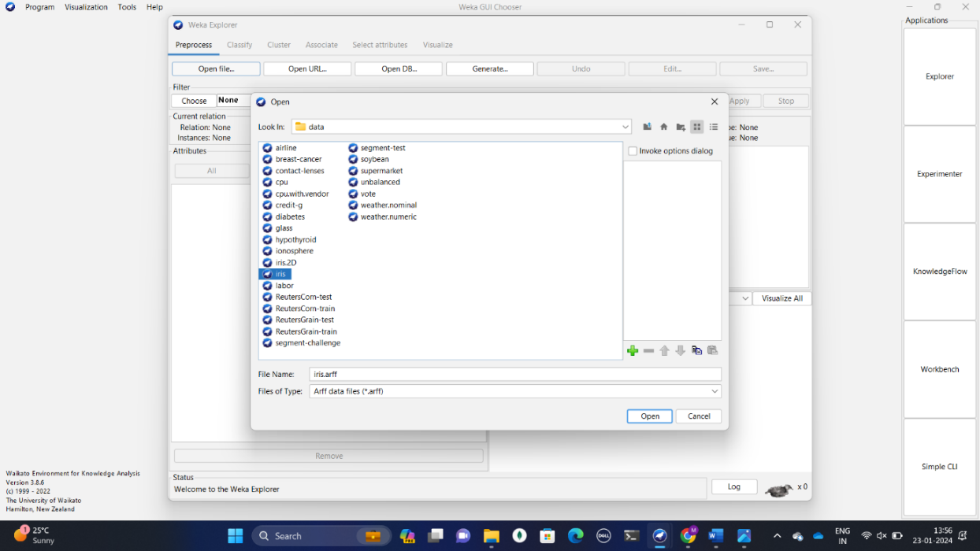 Step 4: select iris database. AS shown in the following fig 2.1.

Figure 2.1 iris database

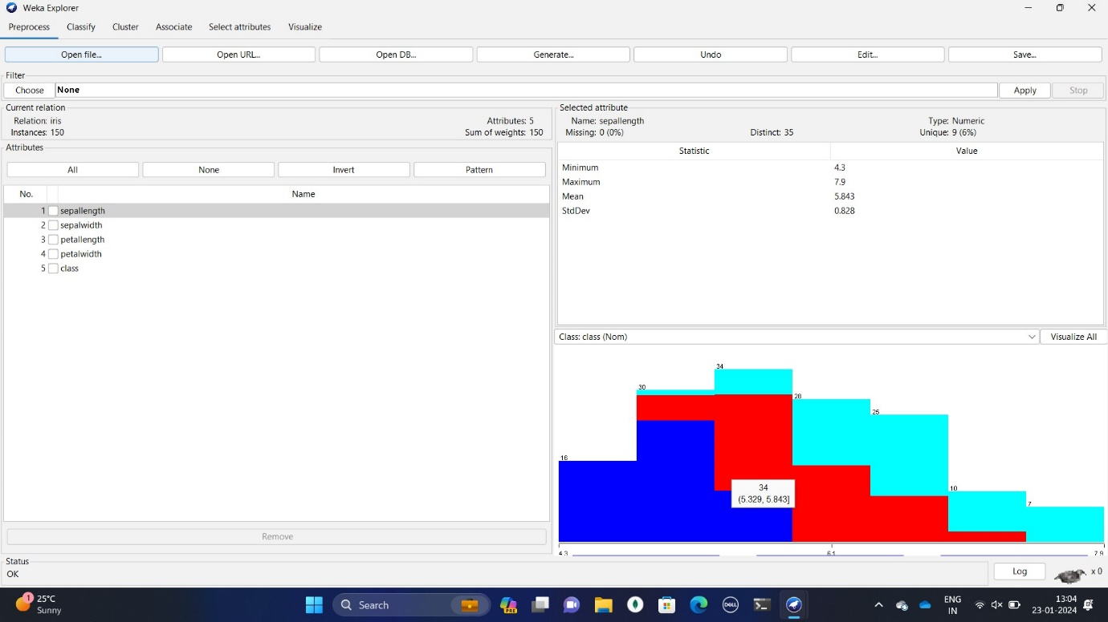Step 5:  After the data is loaded you will see the following fig 2.2

Figure 2.2 Loading data

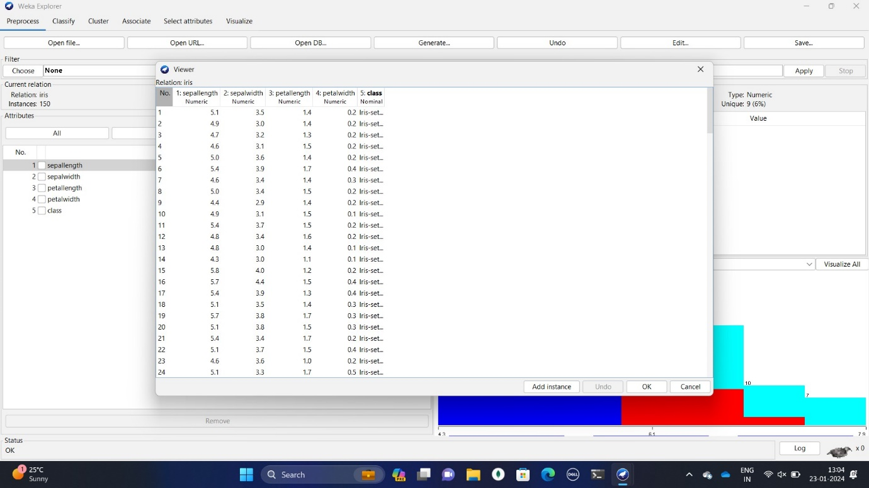Step 6: Click on department database table format and click on edit as shown in fig 2.3 it has 150 rows and 5 column.

Figure 2.3 Data in table format

**3] Cluster:**

**a) SimpleKMean** :K-means clustering is a simple unsupervised learning algorithm. In this, the data objects (‘n’) are grouped into a total of ‘k’ clusters, with each observation belonging to the cluster with the closest mean. It defines ‘k’ sets, one for each cluster k n (the point can be thought of as the center of a one or two-dimensional figure). The clusters are separated by a large distance..

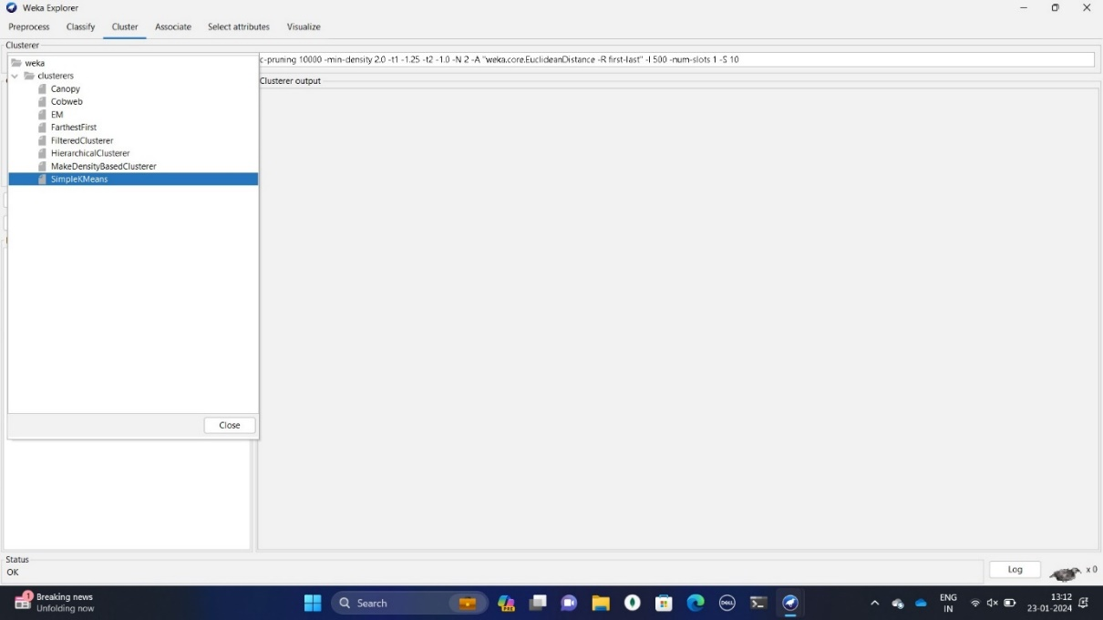Step 1: Click on the Cluster TAB and click on the Choose button. Select the SimpleKMean In fig. 3.1.

Fig 3.1 SimpleKMean

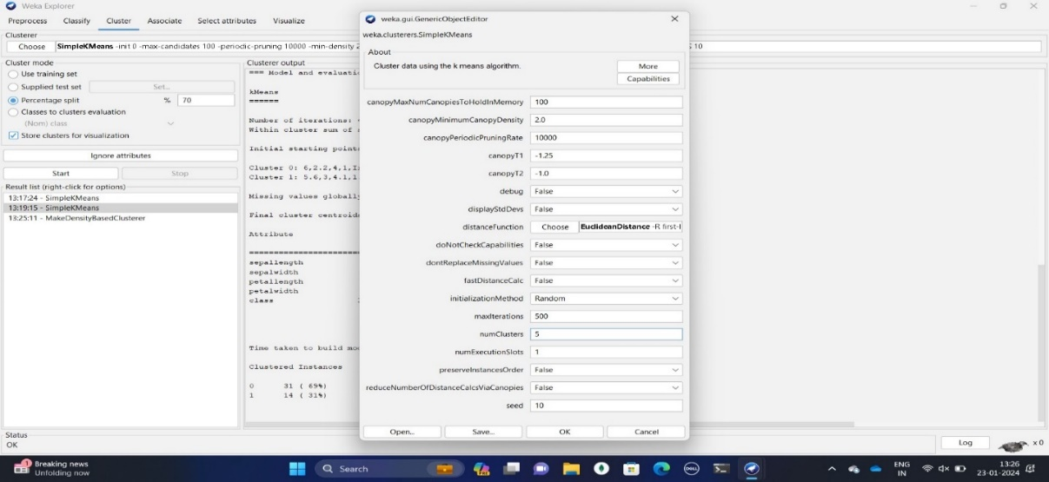Step 2: click on SimpleKMean a new window will open as show in fig 3.2 and change numrules

Figure 3.2 values

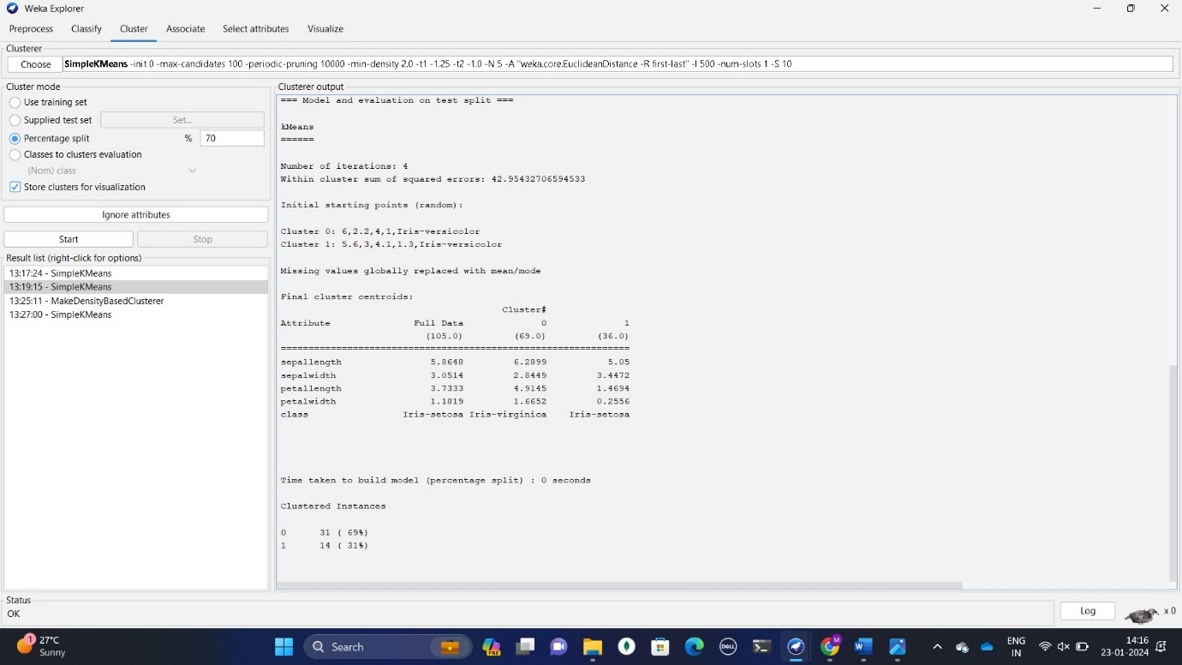Step 3: After changing a rules values and giving percentage spilt 70% then click on ok, as show in fig 3.3

*Fig 3.3 output*

**b) MakeDensityBasedCluster:** Density-Based Clustering refers to one of the most popular unsupervised learning methodologies used in model building and machine learning algorithms. The data points in the region separated by two clusters of low point density are considered as noise.

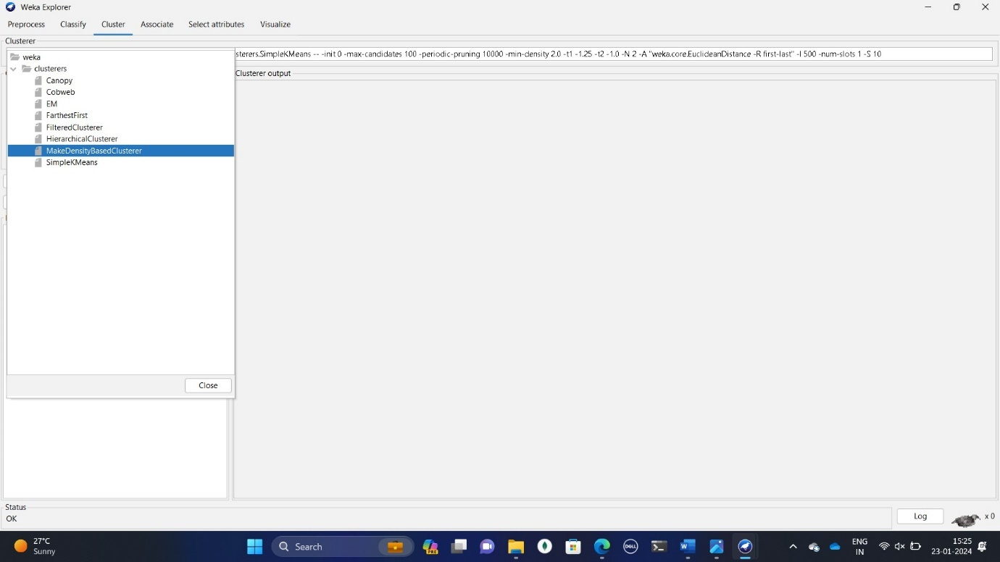Step 1: Click on the Cluster  TAB and click on the Choose button. Select the filter MakeDensityBasedCluster   as Show in fig 3.

Fig 3.4 select filter

Step 2: click on MakeDensityBasedCluster a new window will open as show in fig 3.2 and change numrules

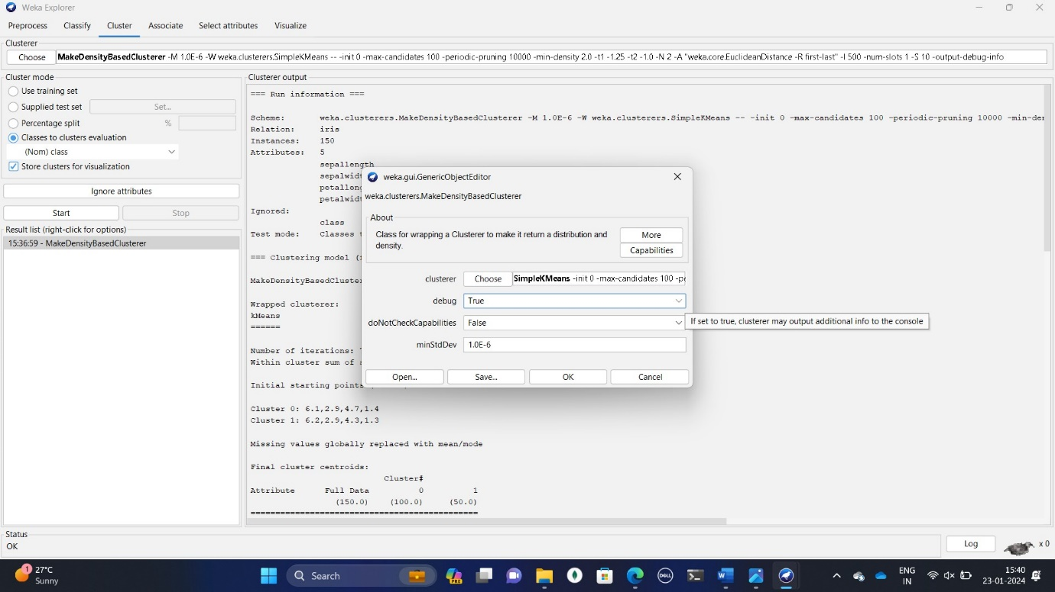Figure 3.5 Editing values

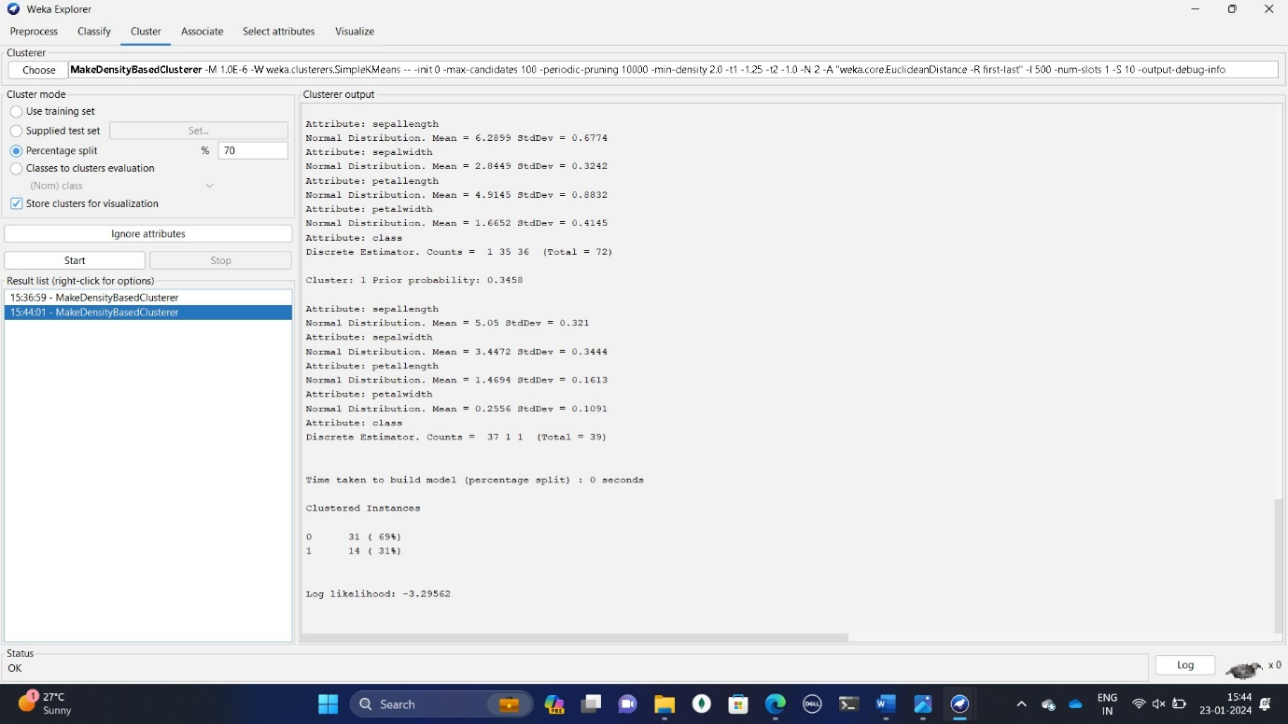–-Step 3: After changing a rules values and giving percentage spilt 70% then click on ok, as show in fig 3.3

Figure 3.3 Output

SimpleKMeans:

|  |  |  |  |
| --- | --- | --- | --- |
| Feature | 40 | 60 | 80 |
| Cluster size 0 | 31(34%) | 17(28%) | 21(70%) |
| Cluster size 1 | 59(66%) | 43(72%) | 9(30%) |

Bestcase :40(87%)

MakeDensityBasedCluster:

|  |  |  |  |
| --- | --- | --- | --- |
| Feature | 40 | 60 | 80 |
| Cluster size 0 | 31(34%) | 17(28%) | 21(70%) |
| Cluster size 1 | 55(66%) | 43(76%) | 9(30%) |

Bestcase:80

**4]Conclusion**: In this practical, we use clustering with Weka using SimpleKMeans and MakeDensityBasedCluster algorithms on the ionosphere dataset shows MakeDensityBasedCluster consistently outperforming SimpleKMeans, with a perfect 100% clustering at Feature 80, making it the preferred algorithm.

**Practical:06**

**Aim:** Perform Binning techniques to smooth out the noise in the dataset.

Theory:

Data binning, **bucketing** is a data pre-processing method used to minimize the effects of small observation errors. The original data values are divided into small intervals known as bins and then they are replaced by a general value calculated for that bin. This has a smoothing effect on the input data and may also reduce the chances of overfitting in the case of small datasets  
There are 2 methods of dividing data into bins:

1. **Equal Frequency Binning:**bins have an equal frequency.
2. **Equal Width Binning :**bins have equal width with a range of each bin are defined as [min + w], [min + 2w] …. [min + nw] where **w = (max – min) / (no of bins).**

Binning method is used to smoothing data or to handle noisy data. In this method, the data is first sorted and then the sorted values are distributed into a number of buckets or bins. As binning methods consult the neighbourhood of values, they perform local smoothing. There are three approaches to performing smoothing –

**Smoothing by bin means** : In smoothing by bin means, each value in a bin is replaced by the mean value of the bin.

**Smoothing by bin median** : In this method each bin value is replaced by its bin median value.

**Smoothing by bin boundary :** In smoothing by bin boundaries, the minimum and maximum values in a given bin are identified as the bin boundaries. Each bin value is then replaced by the closest boundary value.

Program:

import numpy as np

import math

from sklearn.datasets import load_wine

dataset= load_wine()

a = dataset.data

b = np.zeros(40)

for i in range(40):

b[i] = a[i,1]

b = np.sort(b)

bin1 = np.zeros((10,4))

bin2 = np.zeros((10,4))

bin3 = np.zeros((10,4))

for i in range(0,40,4):

k = int(i/4)

mean= (b[i] + b[i+1] + b[i+2] + b[i+3])/4

for j in range(4):

bin1[k,j] = mean

print("Bin Mean: \n",bin1)

for i in range(0,40,4):

k = int(i/4)

for j in range(4):

if(b[i+j]-b[i]) < (b[i+3]-b[i+j]): bin2[k,j]=b[i]

else:

bin2[k,j]=b[i+2]

print("Bin Boundaries: \n",bin2)

for i in range(0,40,4):

k = int(i/4)

for j in range(4):

bin3[k,j]=b[i+2]

print("Bin Median: \n",bin3)

Output:

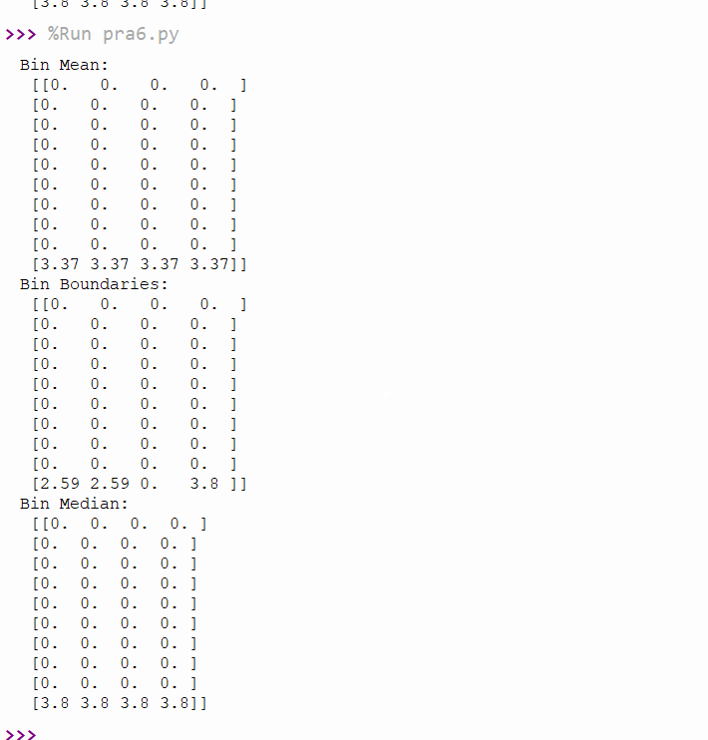

**Conclusion:** Binning is a crucial data preprocessing technique that converts continuous variables into categorical data, simplifying analysis and facilitating insight extraction. Through this practical, we explored its importance in handling complex datasets, managing outliers, and improving model performance.

**Practical:07**

**Aim**: Write a python program for linear regression analysis on the given dataset.

Theory:

Regression defines a type of supervised machine learning approaches that can be used to forecast any continuous-valued attribute. Regression provides some business organization to explore the target variable and predictor variable associations. It is an essential tool to explore the data that can be used for monetary forecasting and time series modeling.

**Linear Regression** − Linear regression includes discovering the “best” line to fit two attributes (or variables) therefore that one attribute can be used to predict the other. Multiple linear regression is an advancement of linear regression, where higher than two attributes are included and the record are fit to a multidimensional area.

For example, the equation is

Y = a + b*X + e.

Where,

a defines the intercept

b defines the slope of the regression line

e defines the error

X and Y define the predictor and target variables, accordingly. If X is create up of higher than one variable, defined as multiple linear equations.

Program:

import numpy as np

import matplotlib.pyplot as plt

from sklearn.model_selection import train_test_split

from sklearn.linear_model import LinearRegression

from sklearn.metrics import mean_squared_error

# Generate sample data

np.random.seed(0)

X = 2 * np.random.rand(100, 1)

y = 3 * X + np.random.randn(100, 1)

# Split the data into training and testing sets

X_train, X_test, y_train, y_test = train_test_split(X, y, test_size=0.2, random_state=42)

# Train the linear regression model

model = LinearRegression()

model.fit(X_train, y_train)

# Make predictions on the testing set

y_pred = model.predict(X_test)

# Calculate the Mean Squared Error

mse = mean_squared_error(y_test, y_pred)

print("Mean Squared Error:", mse)

# Plot the training data, testing data, and the regression line

plt.scatter(X_train, y_train, color='blue', label='Training Data')

plt.scatter(X_test, y_test, color='red', label='Testing Data')

plt.plot(X_test, y_pred, color='green', label='Regression Line')

plt.xlabel('X')

plt.ylabel('y')

plt.title('Linear Regression Analysis')

plt.legend()

plt.show()

Output:

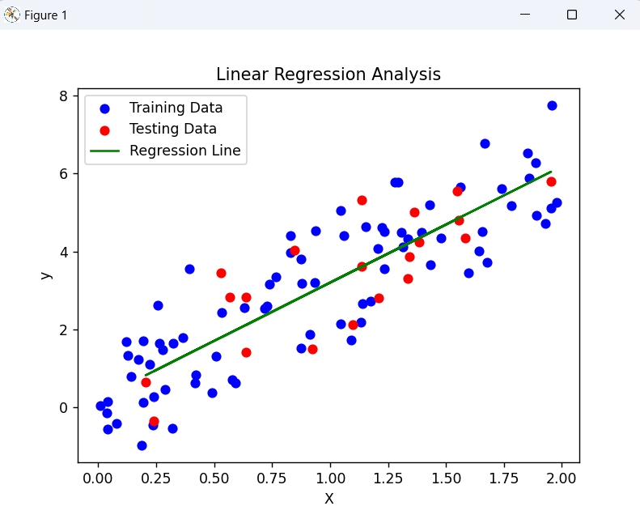

4



**Conclusion:** The linear regression practical showed us how to use basic math to understand relationships between different things in data. We learned how to prepare the data, find patterns by drawing a line through it, and check how well our predictions match reality. By drawing pictures, we could see if our guesses were close to what really happened. This helped us understand how to use numbers to predict outcomes in real-life situation

**Practical :08**

**Aim:** Use python libraries to generate chart from csv data.

Theory:

**Pandas:** Pandas is a Python library designed for data manipulation and analysis. It provides data structures like Series and Data Frames, making it easy to work with labeled and relational data. Pandas is built on top of NumPy and is commonly used for tasks such as cleaning, merging, and analyzing datasets. It is an essential tool for data analysts, scientists, and engineers working with structured data in Python

**Matplotlib:** Matplotlib is a powerful Python library for generating high-quality static, animated, and interactive visualizations. It offers a wide range of tools through its pyplot submodule, allowing developers to easily create charts, graphs, and other graphics. Matplotlib is often compared to MATLAB due to its similarity in usage via the pyplot interface, which consists of a series of commands that modify the state of a figure, making each call build upon the previous ones. This approach simplifies the creation process while still offering flexibility when needed. Matplotlib supports numerous formats and backends, enabling it to adapt to diverse needs and environments.

**Pyplot**: Pyplot is a user-friendly interface for Matplotlib, providing a concise way to generate visualizations without requiring deep knowledge of the underlying architecture. It follows a stateful design, meaning that operations accumulate until either a new figure is opened or the plt.close() function is invoked. Pyplot offers a collection of functions that allow users to perform common tasks such as creating figures, adding plots, setting titles, and showing the resulting graphic. It is particularly useful for rapid prototyping and experimentation because it closely mimics the MATLAB environment

Code:

import csv

from matplotlib import pyplot as plt

filename = 'sitka_weather_2018_full.csv'

with open(filename) as f:

reader = csv.reader(f)

header_row = next(reader)

highs = []

for row in reader:

if row[8]=='':

continue

high = int(row[8],10)

highs.append(high) #appending high temperatures

#Plot Data

fig = plt.figure(dpi = 128, figsize = (10,6))

plt.plot(highs, c = 'red') #Line 1

#Format Plot

plt.title("Daily High Temperatures, 2018", fontsize = 24)

plt.xlabel('',fontsize = 16)

plt.ylabel("Temperature (F)", fontsize = 16)

plt.tick_params(axis = 'both', which = 'major' , labelsize = 16)

plt.show()

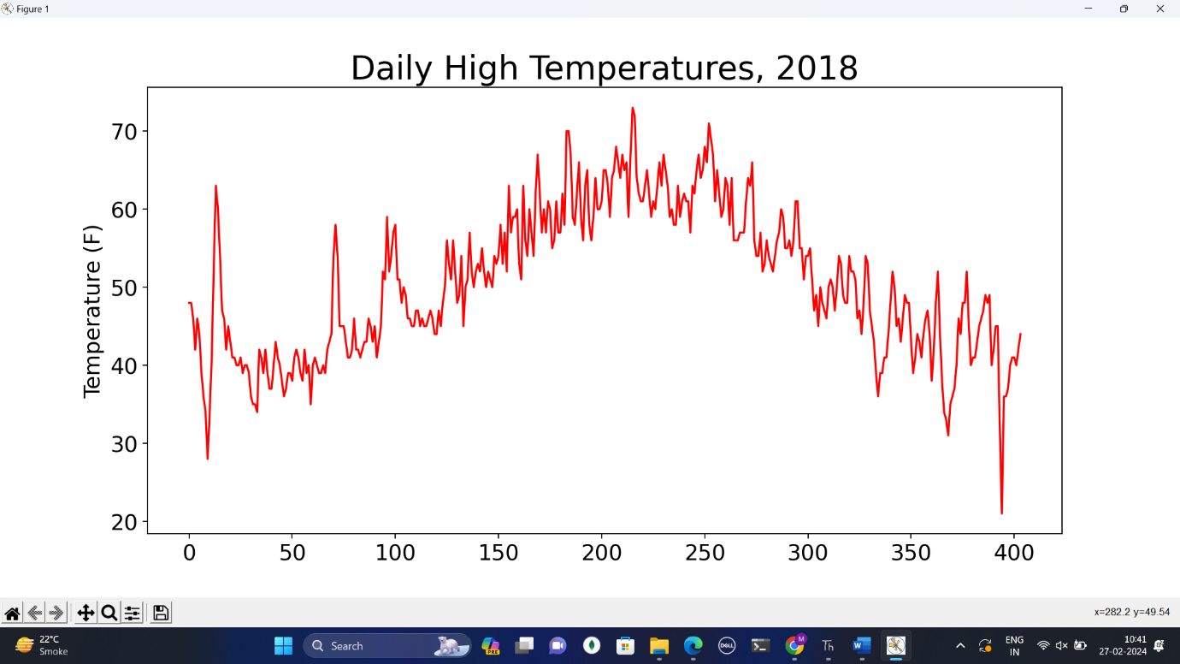Output:

import pandas as pd

**Program:**

import plotly.express as px

df = pd.read_csv('2014_apple_stock.csv')

fig = px.line(df, x='AAPL_x', y='AAPL_y', title='Apple Share Prices over time (2014)') fig.show()

### Output:

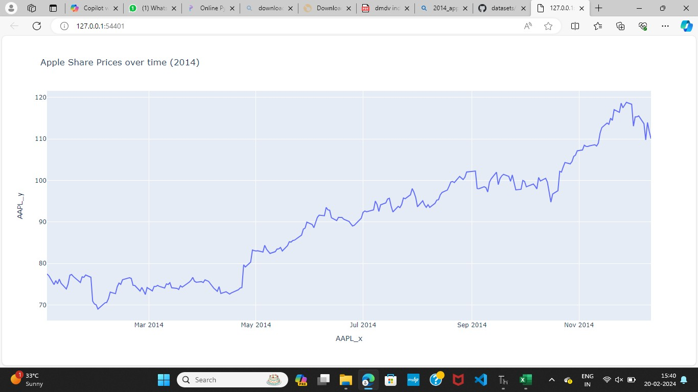[line chart]

**Program:**

import matplotlib.pyplot as plt

year=[2000,2001,2002,2003,2004,2005]

itemA=[400,80,120,300,150,90]

itemB=[120,100,80,120,260,90]

plt.subplot(221)

plt.fill_between(year, min(itemA),itemA, alpha=0.5)

plt.subplot(222)

plt.fill_between(year, min(itemA),itemA, alpha=0.5)

plt.fill_between(year, min(itemB),itemB, alpha=0.5)

plt.show()

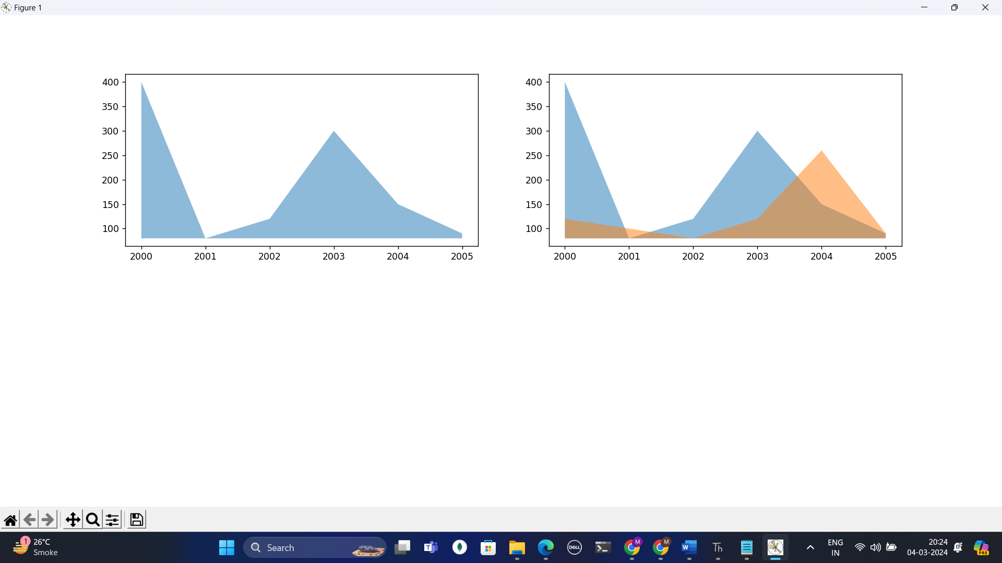Output:

**Program:**

import numpy as np

import matplotlib.pyplot as plt

XA= np.random.uniform(size=20)

YA= np.random.uniform(size=20)

XB= np.random.uniform(size=30)

YB= np.random.uniform(size=30)

plt.scatter(XA,YA,marker='o')

plt.scatter(XB,YB,marker='s')

plt.show()

Output:

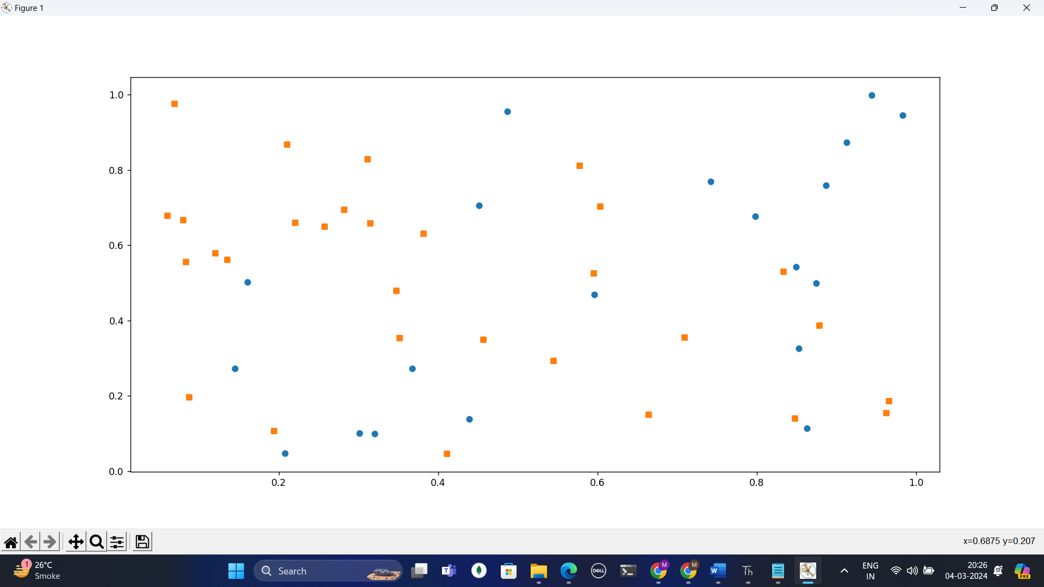

**Program:**

import plotly

import plotly.graph_objs as go

plotly.offline.plot({"data":[go.Scatter(x=[2,4,6,8],y=[6,7,8,3])], "layout": go.Layout(title="Demo")}, auto_open=True)

Output:

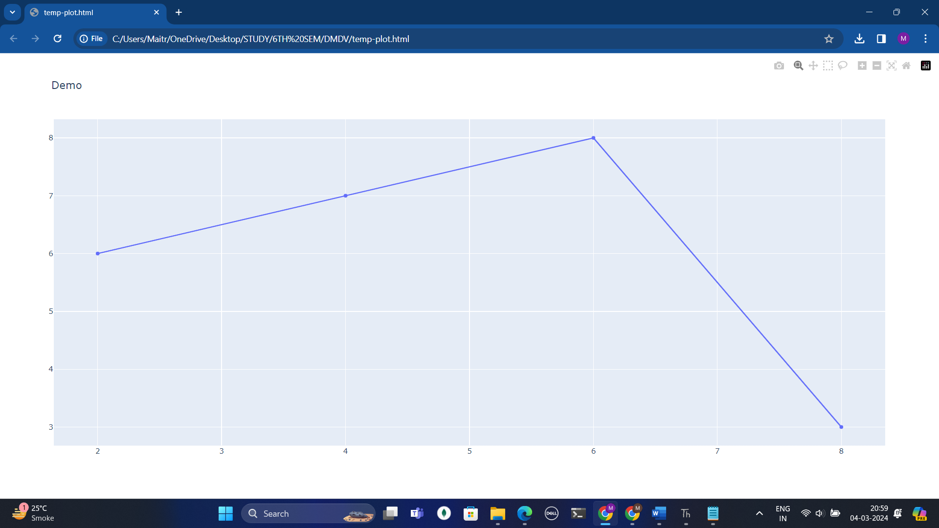

**Program:**

import pandas as pd

impo

rt matplotlib.pyplot as plt

data = pd.Series({'IND':8929,'PRC':7823,'BRZ':6435, 'UK':1023,'US':2003})

plt.subplot(211)

data.plot(kind='pie')

plt.subplot(212)

data.plot(kind='bar')

plt.title("Canada Immigrants")

plt.legend()

plt.show(

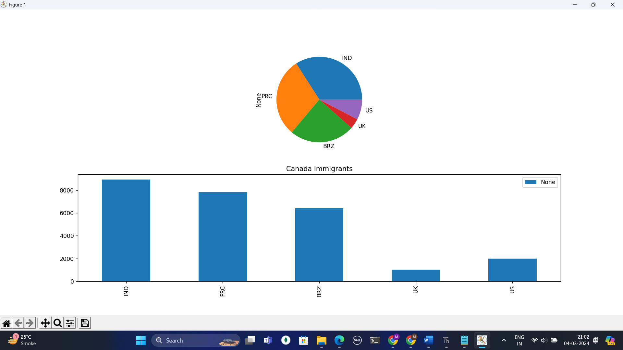Output:

**Program:**

import matplotlib.pyplot as plt

import numpy as np

data = np.random.randn(20)

print (data)

plt.hist(data,20)

plt.title("Normal Distribution")

plt.savefig("HistDemo.png")

plt.show()

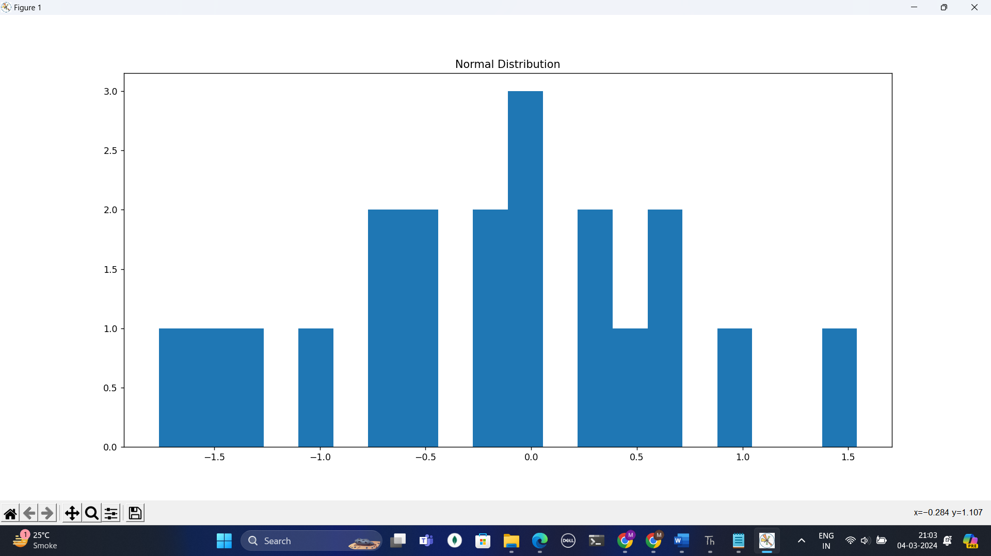Output:

Data output:

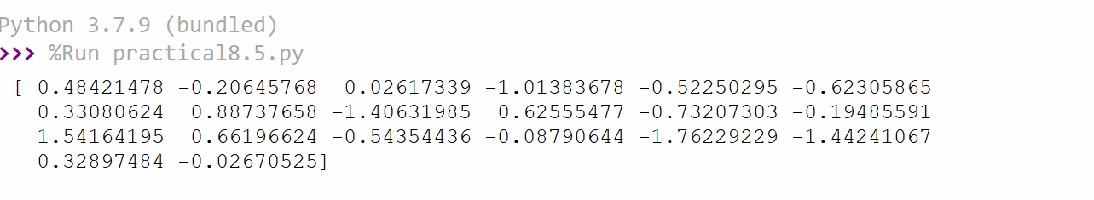

**Conclusion**: Python provides powerful libraries like **pandas**, **matplotlib**, for handling and visualizing data from CSV files. By leveraging these libraries, you can efficiently generate insightful charts and graphs to analyze and communicate your data findings.

**Practical:09**

**Aim:** Study different Data visualization tools.

Theory:

Data and information visualization is the practice of designing and creating easy-to- communicate and easy-to-understand graphic or visual representations of a large amount of complex quantitative and qualitative data and information with the help of static, dynamic or interactive visual items.

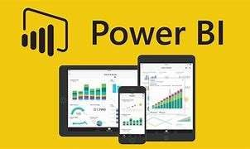**1.Microsoft Power BI**

Microsoft Power BI is a powerful data visualization and business intelligence tool that enables users to connect, analyze, and visualize data efficiently. Here are some key points about Power BI based on the provided search results:

Features: Power BI offers a full variety of visualizations like stacked column charts, matrix charts, filled maps, funnel charts, and waterfall charts. It helps in creating attractive dashboards and reports by taking data from various sources like Excel, SQL Server, and more.

Advantages: Power BI provides a cloud-based and desktop interface, capabilities like data warehousing, data discovery, and interactive dashboards. It allows for loading custom visualizations, scalability across the entire organization, and ease of use with a drag-and-drop interface.

Implementation: Implementing Power BI data visualization involves key steps like data integration, data transformation, report creation, and dashboard implementation. Data integration allows extraction from different sources like Excel files and online servers. Data transformation involves cleaning and pre-processing data for effective visualization. Report creation includes creating visualizations like charts and graphs. Dashboard implementation enables the creation of interactive dashboards for monitoring key metrics.

Custom Visualizations: Power BI offers an extensive library of visuals that can be customized to meet specific requirements. Users can build custom data visualizations beyond the standard library to create unique visuals tailored to their industry or organization.

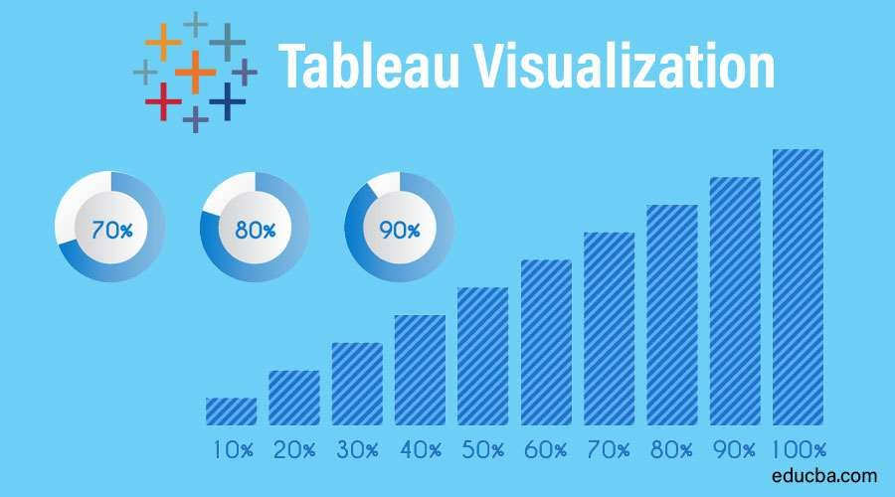**2.Tableau**

Tableau is a highly popular data visualization tool known for its efficiency in transforming raw data into easily understandable formats. Tableau's ability to handle various types of data sources, create interactive visualizations, and offer a seamless user experience has contributed to its popularity as a leading tool for data visualization and business intelligence. Here are some key reasons why Tableau is widely used in the business intelligence industry:

Efficient Data Analysis: Tableau allows users to analyze data quickly and generate visualizations in the form of dashboards and worksheets, providing actionable insights that help businesses make informed decisions.

User-Friendly Interface: One of Tableau's strengths is its user-friendly interface, which enables individuals to work without technical or coding knowledge. The drag-and-drop feature and self-depicting visualizations make it accessible even to users without prior skills in data analysis.

Data Connectivity: Tableau can connect to various data sources, including data warehouses, cloud files, big data, spreadsheet data, and non-relational data. This capability allows organizations to blend different types of data for creating compelling visualizations.

Industry Adoption: Tableau is widely adopted by Fortune Global 500 companies and has a significant market share in the Business Intelligence category. Its scalability, ease of deployment, and trendiness make it a preferred choice for organizations looking to analyze large datasets efficiently.

Powerful Features: Tableau offers powerful data discovery and exploration tools that enable users to answer critical questions rapidly. It supports creating reports by joining and blending diverse datasets, providing a comprehensive platform for visualizing and analyzing data.

**3.Google Data Studio:**

Google Data Studio is a free, web-based tool that allows you to create visually appealing and informative dashboards and reports from your data. It doesn't require any coding knowledge and offers an easy-to-use interface for anyone to get started.

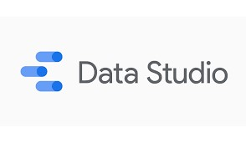

**Key features of Google Data Studio**:

* **Data Source Integration:** Connects to various data sources like Google Analytics, Google Ads, spreadsheets, and databases.
* **Drag-and-Drop Functionality:** Build reports and dashboards by simply dragging and dropping charts, graphs, and other elements onto a workspace.
* **Customization Options:** Extensive customization options allow you to tailor the look and feel of your reports to match your brand identity.
* **Collaboration Features:** Collaborate with colleagues on reports in real-time, allowing for shared editing and feedback.
* **Interactive Features:** Create interactive reports with filters and drill-down capabilities for users to explore the data further.

**Benefits of Using Google Data Studio:**

* Easy to Use: No coding required, making it accessible to a wider audience.
* Visually Appealing Reports: Create clear and informative reports that are easy to understand.
* Data Sharing and Collaboration: Share reports and collaborate with others in real-time.
* Free for Up to 5 Reports: Great for individuals and small businesses.

**4. D3.js:**

D3.js, short for Data-Driven Documents, is a free, open-source JavaScript library specifically designed for creating dynamic, interactive data visualizations in web browsers. It offers a low-level approach that gives you a high degree of control and flexibility in crafting your visualizations.

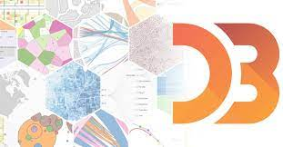

**Key features of D3.js:**

**Core Functionality:**

* **Data Manipulation:** D3.js doesn't handle data acquisition itself. Instead, it focuses on manipulating and transforming your existing data for visualization.
* **DOM Manipulation:** D3 interacts directly with the Document Object Model (DOM), the core representation of a webpage. It allows you to create, update, and remove HTML elements based on your data.
* **Scalable Vector Graphics (SVG) and Canvas:** D3 works seamlessly with SVG and Canvas elements, the primary web technologies for creating vector graphics and dynamic imagery. This enables you to build rich and interactive visualizations.

Key Advantages of D3.js:

Flexibility: D3.js offers fine-grained control over every aspect of your visualization, allowing you to create unique and tailored visuals.

Interactivity: You can incorporate user interaction elements like zooming, panning, filtering, and highlighting data points to make your visualizations more engaging and informative.

Customization: D3 provides a wide range of built-in functions and modules for common visualization tasks like creating charts, graphs, maps, and more. You can also extend its functionality by writing custom code.

Open-Source Community: D3 benefits from a large and active open-source community that contributes to its development and offers extensive resources and tutorials.

1. **Datawrapper:**

Datawrapper is an online tool specifically designed to help people create beautiful and informative charts, maps, and tables from their data. Here's a breakdown of its key features:



**Key Features of Datawrapper:**

* **Ease of Use:** Designed for simplicity, Datawrapper doesn't require coding knowledge. It offers a user-friendly interface for creating visualizations step-by-step.
* **Variety of Visualizations:** It provides a wide range of chart types (bar, line, pie, scatter etc.), map options (choropleth, symbol, locator), and tables with features like mini-charts and heatmaps.
* **Data Privacy:** Datawrapper prioritizes security. Your data remains private by default while you create visualizations, and you control when to publish them.
* **Collaboration:** Basic collaboration features allow you to share your creations for viewing and commenting with others.
* **Free and Paid Plans:** A free plan offers basic features, while paid plans unlock advanced customization, exporting options, and higher data upload limi

**Conclusion**: In conclusion, exploring various visualization tools reveals a diverse landscape catering to different user needs and preferences. Each tool offers unique features and capabilities, ranging from interactive dashboards to advanced analytics and collaboration options. Understanding these distinctions empowers users to select the most suitable tool for their specific data visualization requirements.

**Practical:10**

**Aim:** Case Study: Interactive Data Analytics with Power BI

**What is Power BI?**

Power BI is a robust tool for interactive data analytics and visualization, offering a range of features that streamline the process of transforming raw data into actionable insights. Here is an overview of the key points highlighted in the provided search results:

**Visual Data Analytics**: Power BI simplifies the creation of interactive visualizations and business intelligence reports through a user-friendly interface. It allows for easy sharing of insights with stakeholders by storing data in the cloud and enabling report embedding on collaborative platforms like Microsoft Teams and SharePoint.

**Ease of Use**: Power BI's drag-and-drop interface makes it accessible to users without extensive technical knowledge, allowing for quick creation of impressive interactive reports and dashboards. The tool offers an extensive library of visualizations that can be customized to meet specific requirements.

**Data Connectivity**: Power BI can connect to various data sources, including Excel, SQL Server, and cloud-based repositories, making it a versatile choice for data scientists and analysts. Its compatibility with multiple sources enhances its flexibility in handling diverse datasets.

**Implementation Steps**: Implementing Power BI for data visualization involves key steps like data integration, data transformation, report creation, and dashboard implementation. These steps ensure that data is cleaned, pre-processed, visualized effectively, and shared with stakeholders for informed decision-making.

**Advantages**: Power BI provides cloud-based and desktop interfaces, capabilities like data warehousing, interactive dashboards, and custom visualizations. It offers scalability across organizations and ease of use with a drag-and-drop interface, making it a valuable tool for businesses seeking efficient data analysis solutions.

**Real-Time Data Analysis**: Power BI enables real-time data analysis by connecting to live data sources and updating visualizations dynamically. This feature allows users to monitor key metrics and make informed decisions based on the most up-to-date information available.

**Advanced Analytics:** Power BI offers advanced analytics capabilities through integrations with Azure Machine Learning and R programming language. Users can perform predictive analytics, clustering, and other advanced statistical analyses within the Power BI environment, enhancing the depth of insights derived from data.

**Collaboration and Sharing**: Power BI facilitates collaboration among team members by allowing users to share reports and dashboards securely. With features like row-level security and integration with Microsoft 365 tools, organizations can ensure that data is shared appropriately while maintaining data security and compliance standards.

**Mobile Accessibility**: Power BI provides mobile apps for iOS, Android, and Windows devices, enabling users to access reports and dashboards on the go. The responsive design of Power BI visuals ensures a consistent user experience across different devices, making it convenient for users to stay connected and informed wherever they are.

**Data Governance and Compliance**: Power BI offers robust data governance features such as data lineage tracking, access controls, and compliance certifications like GDPR and HIPAA. These features help organizations maintain data integrity, security, and regulatory compliance while leveraging the power of interactive data analytics.

**What is Power BI used for?**

There are various tools and techniques for analytics and machine learning in the fascinating and extensive realm of data science. Power BI is a high-level, all-in-one solution for data analytics in data science. Data science aids in the discovery of relevant and productive trends and insights. It involves analyzing the data and assists us in identifying entirely new features in it. Business intelligence is sifting through data to extract meaningful organizational ideas and insights. BI enhances and strengthens the business infrastructure to get desired or projected results.

Many data sciences and analysis tasks can be automated with Power BI, eliminating the need for spreadsheets and static presentation tools. One of Power-most BI's most impressive features is its ability to create stunning visualizations. The software is packed with excellent and eye-catching visualization templates. The integration of Power BI into Data Science holds great importance for businesses. This allows for smooth and effective data visualization, which plays a vital role in an organization’s success.

**How To Do Visualization in a Power BI Project?**

There are two ways to generate visualization in Power BI. First, add items to Report Canvas from the right-side pane. Another way you can do this is by dragging the fields from the right sidebar to the value axis under Visualization. By default, Power BI selects the table type visualization. To each axis, you can add as many fields as necessary. You can also click and drag your visualization to rearrange it on the reporting panel. You can easily toggle between various charts and visualizations from the Visualization window. Your specified fields are transformed to the new visual format as accurately as possible.

The first thing you need is data. Power BI can connect several data sources- Excel, Web, etc. The options from which data can be imported into the Power BI desktop are all visible once you click the Get Data icon. You can view the data in the Fields pane once it has been loaded.

After loading the sample data into the Power BI desktop, you can modify it with the help of Query Editor. Regardless of the data source, query editors are helpful for editing datasets. In the query editor, you can perform changes like renaming a dataset and removing one or more columns, among other things.

In Power BI, removing columns from the dataset or modifying the data types in the columns is relatively easy. You can remove columns by simply choosing the Remove Columns option after selecting the desired column. Likewise, the query editor makes it simple to perform a wide range of actions like removing and adding rows, transposing, pivoting, and splitting.

Once the dataset is complete and has undergone all necessary modifications, you can move on to creating the dashboard. Both bubble and shape maps are available for map visualizations in Power BI. To plot measure values, Power BI offers several combination chart types. Suppose you want to display overall sales and revenue on the same chart. The ideal option for this type of scenario is combination charts.

You can change the colours in the charts in BI dashboards. There is a colour selection option when you choose any visualization.

Additionally, the application has analytics feature that allows you to draw lines for data visualization according to your preferences. Power BI also has the option to add various shapes, texts, and images when visualizing data.

**Website Traffic Analysis**

Website traffic analysis is a framework that combines various metrics and data points to understand user behaviour on a website. Here's a breakdown of the core aspects:

1. **Data Collection:** The foundation relies on gathering data about visitors using analytics tools. This data includes:
   * **Quantity:** Total visitors, page views, sessions.
   * **Source:** Where visitors came from (search engines, social media, referrals).
   * **User Behavior:** Clicks, time on page, bounce rate (visitors leaving after one page).
2. **Traffic Segmentation:** Traffic is then divided into segments based on different criteria like:
   * **Source:** Organic traffic (search engines) vs Paid Traffic (advertisements).
   * **Demographics:** Location, age, gender (if available).
   * **Device:** Desktop, mobile, tablet.
3. **Analysis and Interpretation:** Once segmented, data is analyzed to answer questions like:
   * **What content resonates with users?** (High traffic pages)
   * **Are marketing efforts effective?** (Traffic from campaigns)
   * **Is the website user-friendly?** (Low bounce rates)
4. **Action and Optimization:** Insights are used to improve the website and user experience:
   * Content creation based on user interest.
   * Optimizing marketing campaigns for better reach.
   * Improving website design and navigation for better engagement.

By continuously collecting, analyzing, and acting on website traffic data, businesses can achieve their goals, whether it's increasing sales, brand awareness, or user engagement.

**Data Acquisition: The Foundation of Your Analysis  for this**

It refers to the crucial first step of gathering the information needed to understand your website's visitors and their behavior. This data is the building block for all your website traffic analysis.

Here's how data acquisition plays a vital role in the scenario:

* **Identifying the Traffic Surge:** You wouldn't have known about the recent increase in traffic without data on website visits. This data allows you to track trends and identify anomalies.
* **Source of Traffic:** Understanding where visitors come from (social media, search engines, etc.) helps you attribute the surge to the popular Pinterest board.
* **Visitor Behavior:** Data on clicks, time spent on pages, and bounce rates reveals how visitors interact with your website.

Without this acquired data, you wouldn't be able to diagnose the problem (high bounce rate for Pinterest traffic) and take corrective actions (optimizing earring pages and creating a landing page).

**Data Modelling: Building the Framework**

In our website traffic analysis scenario, data modelling in Power BI Desktop involves structuring your imported data to facilitate insightful analysis. Here's how it translates to our case:

1. **Identifying Relationships Between Tables:**

* We likely have two main data sources:
  + Website Traffic Data: Contains metrics like sessions, bounce rate, source (including Pinterest). Imported from Google Analytics or similar tool.
  + Product Data: Contains details about your products (including earrings). Imported from your e-commerce platform.
* The key relationship between these tables is likely the product. Traffic data might have a field for "product page viewed" which can be linked to a product ID in the product data table.

2. **Defining Tables and Columns:**

* Website Traffic Table: This table would likely include columns like:
  + Time
  + Page Category
  + Source (Organic, Social Media etc.)
  + Bounce Rate
  + Page Views
  + Product Page Viewed (linked to product ID)
  + Age
* Product Table: This table would likely include columns like:
  + Product ID
  + Product Name
  + Category (Earrings in our case)
  + Price
  + Description

3. **Defining Relationships:**

* In Power BI Desktop, you can establish a relationship between the "Product Page Viewed" field in the website traffic table and the "Product ID" field in the product table.
* This relationship allows you to join the data sets and analyze website traffic data alongside product details (e.g., see which earrings are most viewed by Pinterest traffic).

4. **Dimension vs. Measure Tables:**

* In our scenario:
  + Dimension Tables: Website Traffic table (contains descriptive attributes like source, date) and Product table (contains product details).
  + Measure Table: You might create a separate table to house calculated metrics like conversion rate (purchases/sessions) or total revenue generated from Pinterest traffic

**Building the Website Traffic Analysis Dashboard: A Visual Powerhouse:**

Now that you have imported and modeled your data in Power BI Desktop, it's time to create a visually compelling dashboard to analyze your e-commerce website traffic, specifically focusing on traffic from Pinterest.

Dashboard Design Considerations:

* **Target Audience:** Tailor the dashboard to your audience (e.g., marketing team, business owner). Focus on presenting key metrics and insights clearly.
* **Layout and Visualizations:** Use a clean layout with a logical flow of information. Employ charts and graphs that effectively communicate trends and patterns.
* **Metrics Selection:** Include relevant metrics like:
  + **Overall Traffic Trends:** Show website traffic over time, highlighting the recent surge.
  + **Source of Traffic:** Visually represent the proportion of traffic coming from Pinterest compared to other sources.
  + **Pinterest Traffic Behavior:** Analyze bounce rate, time spent on site, and product page views specifically for Pinterest traffic.
  + **Earrings Performance:** Identify which earrings are most viewed and potentially purchased by Pinterest visitors (link website traffic data to product data using the established relationship).

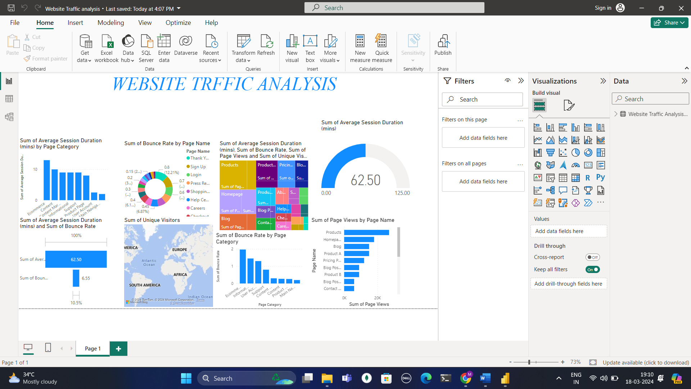

**Conclusion**: In this practical scenario, we explored how to analyze e-commerce website traffic with a focus on visitors coming from Pinterest. We learned the importance of data acquisition, data modelling in Power BI Desktop, and building a visually informative dashboard. By following these steps and leveraging website traffic analysis, you can gain valuable insights to optimize your website and drive sales.